Years 10/11

Section 1: Asking Questions

Session | Title | Key ideas
10-1 | Is There A God? | The hypothesis ‘God exists’ provides, for some scientists at least, a satisfactory philosophical foundation upon which to base scientific research.
10-2 | Why do Natural Disasters Happen? | Responses to the problem of evil and suffering by a professor at Cambridge University.
10-3 | Why are there so many religions? | An exploration of the question of whether any one religion is exclusively true, or whether there are many paths to God.

Teacher Background

These lessons consider three of the key questions which must be addressed before the science-religion debate can be properly tackled. In many cases, students assume that due to the lack of evidence for God’s existence, and the presence in the world of natural disasters and a plurality of religions, the science-religion debate is not even worth having. By addressing these key concerns head on, this unit aims to encourage students to engage with the possibility, explored more fully later on, that science and religion may be compatible rather than simply in conflict.

This unit and Key Stage 4

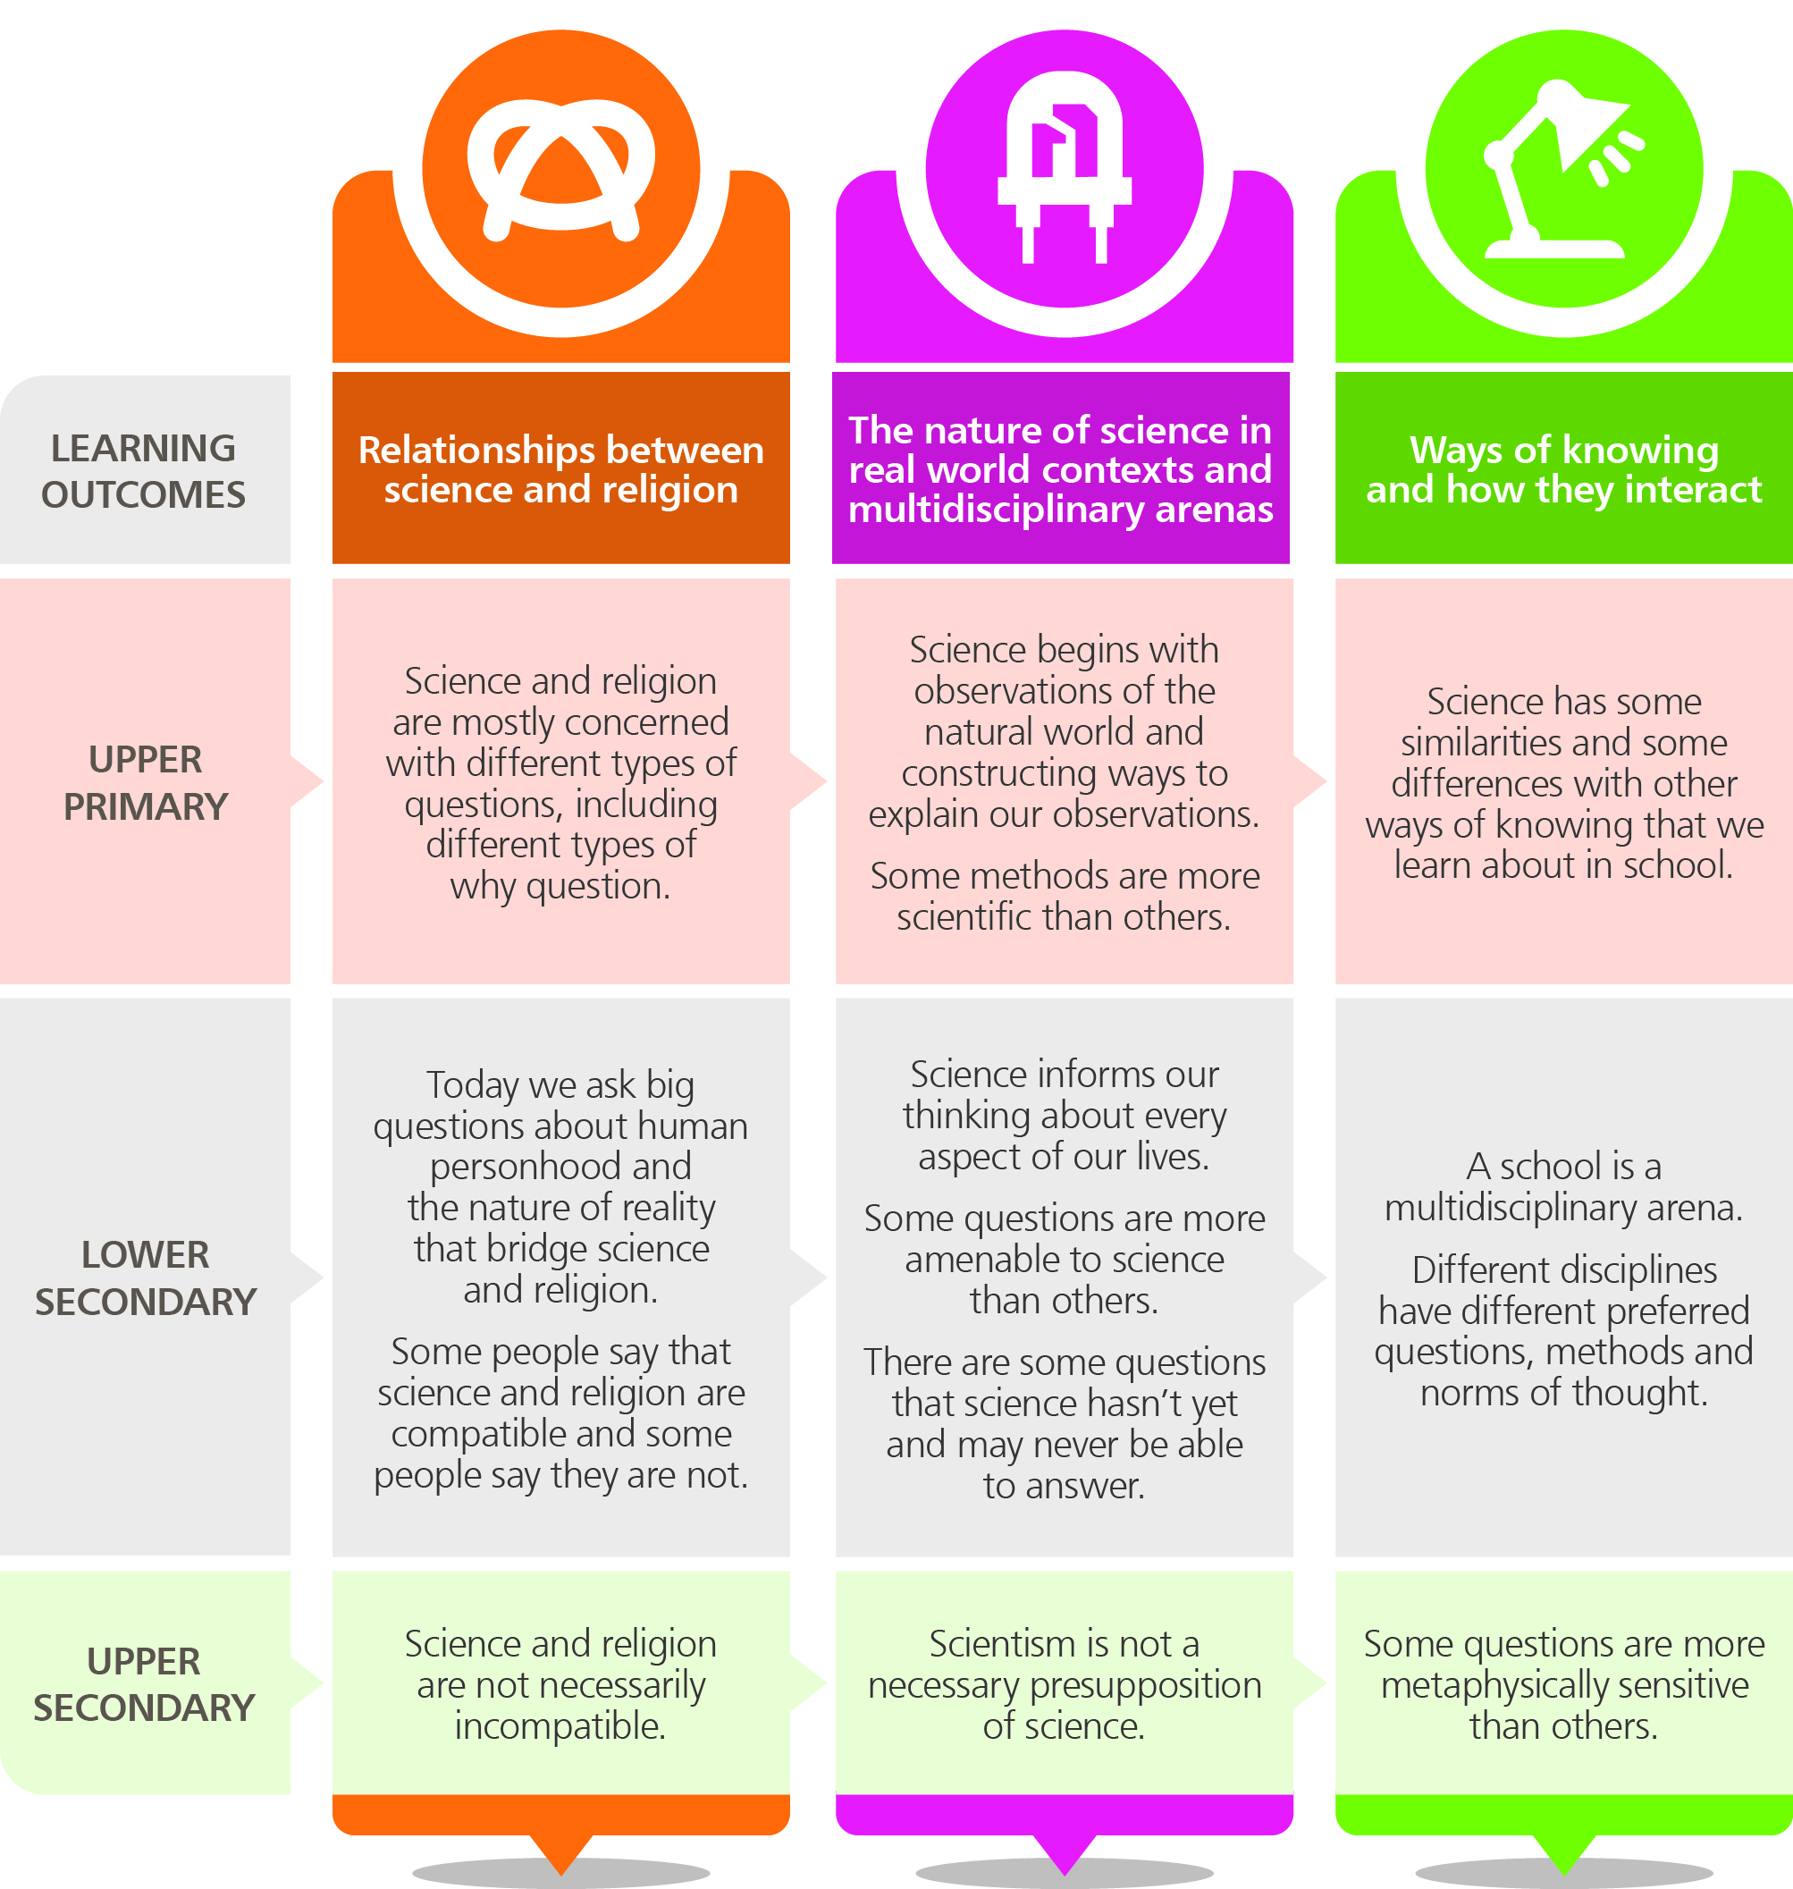
This resource offers a learning journey to take pupils from Year 7 to 11, captured here in our Epistemic Insight Curriculum Framework:

This year 10-11 unit builds substantially on the 7, 8 and 9 units. It addresses the following key learning outcomes from the framework:
1. Science and religion are not necessarily incompatible
- The hypothesis ‘God exists’ provides, for some scientists at least, a satisfactory philosophical foundation upon which to base scientific research.

Session 1: Is There A God?

Resources
Title | Type
‘Why Do You Believe In God?’ | Video (2 mins)
‘How Do I Obtain Reliable Knowledge About the World?’ | Article, on website
Note: Videos can be found on the relevant web page and within the video gallery

Overview

It is commonly assumed that science and religion are in conflict, and that ‘science has disproved religion’ (an attitude exemplified by Richard Dawkins’ characteristic quotation ‘I am against religion because it teaches us to be satisfied with not understanding the world’). However the relationship between science and religion is more complex than this point of view suggests, and both today and in the past there have been many prominent individuals in both the scientific and religious communities who have been religious believers and committed to rigorous scientific investigation. Students should be helped to understand that science can just as easily be seen as in harmony with religion as in opposition to it, and they should be encouraged to assess this perspective for themselves.

Lesson objectives

Most students should be able to:

- Explain why science and religion are often held to be in conflict.
- Appreciate that not all scientists and not all religious believers agree that science and religion are in conflict.
- Articulate at least one argument which supports the view that science and religion are compatible.

Some students should be able to:

- Assess and evaluate Dr Louis’ argument that religious faith gives science more robust philosophical foundations than an atheistic worldview.

Keywords

argument; hypothesis; naturalistic; uniformity; worldview.

Lesson Outline

Starter

Begin with a ‘spectrum of belief’, and impress upon the students that this activity works best if they are willing to approach it with an open mind, to have their assumptions challenged, and even to change their views during the lesson. Assign three areas of the classroom as ‘strongly agree’, ‘neutral’ and ‘strongly disagree’, and then read out the following statements. After each one, the pupils should move to the area of the room which best reflects their response to the statement. When they have decided where to go, ask them to get into groups of three or four, and be ready to offer a justification for their view, and you could also ask them to try to persuade the rest of the class to move to join them. After each group has presented their argument(s), ask if anyone would like to move, and, if so, what it is that convinced them to change their mind. Try the following three statements, and add more of your own if you would like to extend the activity:

- Science has disproved God
- There is no evidence for the existence of God
- Believing in God makes sense of the beauty and complexity of the world.

Activity 1: Is there a God?

Resources: ‘Why Do You Believe in God?’ (video, 2 minutes)

Explain to the students that while many people assume that science and religion are opposed to one another, there are actually many scientists who also believe in the divine, and that despite the popular views of Richard Dawkins and other prominent atheists, the question of God’s existence is more complicated than simply asserting that ‘science has disproved religion’.

Introduce the video in which Dr Ard Louis, a Reader in Theoretical Physics at Oxford University, explains his perspective on the question of whether or not God exists. Ask the students to be ready to summarise in their own words after watching the video Dr Louis’ reasons for having faith in God.

Show them the video, and afterwards give them five minutes to write a paragraph summarising Dr Louis’ reasons for believing in God.

Ask two or three students to read their paragraphs out, and make sure that everyone has grasped Dr Louis’ central argument that for him, God’s existence explains the characteristics of the universe that make science possible, such as ‘uniformity’. You could compose a model summary paragraph as a class, and have everyone copy it out. Discuss with the students whether or not they agree with Dr Louis’ position, and why.

Plenary

Remind the students of one or more of the classical arguments for the existence of God (e.g. the Ontological Argument, the Argument from Religious Experience, the Cosmological Argument etc). Discuss how Dr Louis’ main reason for believing in God compares with these other arguments. Is his position stronger or weaker than the classical argument(s)? Why? Does a ‘scientific worldview’ have any implications for the classical argument(s) for the existence of God? (e.g. some would argue that modern science has disproved, or at least explained to some degree, the phenomena of religious experience. Do the students agree that modern science has weakened this argument for the existence of God?).

Homework/further research

Distribute copies of Dr Louis’ article ‘How can we obtain reliable knowledge about the world?’ (download from the Never off Topic website), and set the students the task of reading it and writing answers to the following questions:

- What is ‘critical realism’?
- On what grounds does Dr Louis argue that there are limits to science?
- How does Dr Louis use the examples of marriage and the legal process to argue that there are rational but non-scientific ways of looking at the world?
- How does Dr Louis respond to the question of whether he finds there to be a tension between his reading of the Bible and his work as a scientist?
- How does Dr Louis argue that God interacts with the world?
- Dr Louis writes: ‘As a scientist, I feel the Bible provides a rich and harmonious framework within which to understand why the world around me is regular.’ What does he mean?
- Why does Dr Louis believe that faith in God provides a more satisfactory philosophical basis for science than atheism?

Session 2: Why Do Natural Disasters Happen?

Resources
Title | Type
Why are there natural disasters if God created the world? | Video (4 mins)
Why are there natural disasters? | Video (2 mins)
Note: Videos can be found on the relevant web page and within the video gallery

Overview

The problem of suffering is one of the most significant arguments against the existence of God. This session explores a possible Christian response specifically to the problem of natural disasters.

Lesson objectives

Most students should be able to:

- Articulate why natural disasters require explanation from a religious point of view.
- Explain how Professor Bob White, as a Christian, is able to believe that God exists despite natural disasters.

Some students should be able to:

- Evaluate the Christian response to natural disasters as articulated by Bob White.

Keywords

compassion; judgement; moral evil; natural evil.

Lesson Outline

Starter

Distribute copies of old newspapers to the class and ask students in pairs or threes to find examples of stories concerning suffering (or ask students to bring in their own examples from home). Categorise the stories as examples of ‘moral evil’ or ‘natural evil’, and discuss which of these two categories poses a more serious threat to religious faith. Discuss why this should be so, and draw out the idea that while moral evil can generally be attributed to the actions of humans rather than God, natural suffering is more difficult for believers to explain. How can a loving God allow natural disasters to take place?

Activity 1: ‘Reconciling Natural Disasters to the Existence of God’

Resources: ‘Why are there natural disasters if God created the world?’ (video, 4 minutes)

Ask the students to be ready to summarise Professor White’s responses to the question of how God could allow natural disasters to happen. After watching the video, draw out the following points as a class, and have the students write down a summary along the following lines:

- It is important first and foremost to have compassion for those who have suffered and are suffering in natural disasters.
- Jesus warned that there is something worse than suffering in a disaster (i.e. death and the judgement of God). Therefore having a right relationship with God is an even more important issue than being able to explain how God could allow these disasters to happen.
- Processes which cause natural disasters (e.g. volcanoes and earthquakes) are part of the fabric of the world which makes it a fertile place to live.
- Human factors (like overcrowding and poor construction) make the impact of natural disasters far worse.

Discuss each of these points. Do the students agree with the Professor?

Plenary

Play the video clip of Rowan Williams explaining how he is able to reconcile religious faith with the existence of natural evil. Do the students agree? What do they think of his argument?

Homework/further research

Give the students one or more of the following quotations from C. S. Lewis’ book The Problem of Pain (1940), or, for more able ones, give them longer extracts to read. Ask them to compose a poem or reflective essay in response to what they have learned in this lesson, and from the quotes below, from either a religious or an atheist perspective as they prefer.

‘We can ignore even pleasure. But pain insists upon being attended to. God whispers to us in our pleasures, speaks in our conscience, but shouts in our pains: it is his megaphone to rouse a deaf world.’

‘Try to exclude the possibility of suffering which the order of nature and the existence of free-wills involve, and you find that you have excluded life itself.’

‘The problem of reconciling human suffering with the existence of a God who loves, is only insoluble so long as we attach a trivial meaning to the word ‘love’, and look on things as if man were the centre of them. Man is not the centre. God does not exist for the sake of man. Man does not exist for his own sake. ‘Thou hast created all things, and for thy pleasure they are and were created.’ We were made not primarily that we may love God (though we were made for that too) but that God may love us, that we may become objects in which the divine love may rest ‘well pleased’.’

Session 3: Why Are There So Many Religions?

Resources
Title | Type
‘Why are there different faiths?’ | Video (2 mins)
Investigation Sheet 1: One Way to God, or Many? | Worksheet
Note: Videos can be found on the relevant web page and within the video gallery

Overview

Alongside the problem of evil, religious pluralism is arguably the most significant objection raised against religious faith today. This session will look at the question of why there are so many religions, and encourage students to reflect upon and evaluate the concepts of theological inclusivism and theological exclusivism.

Lesson Objectives

Most students should be able to:

- Summarise the difference between religious inclusivism and exclusivism.
- Explain why Christianity has historically been theologically more exclusivist than inclusivist.
- Explain the most significant Christian explanations for the existence of other religions.

Some students should be able to:

- Evaluate theological exclusivism.

Keywords

evangelism; exclusivism; the Fall; inclusivism; missionary; Satan.

Lesson Outline

Starter

Draw up an ‘A-Z’ list on the board, and set the students the task (probably in pairs) of coming up with a religion or religious movement) beginning with each successive letter of the alphabet (e.g. Apostolic Church of Christ, Bahai, Christianity etc).

Compose a list altogether, and move into a discussion of why the students think there are so many religions. Is this a problem, or a good thing? How have particular religions themselves responded to the existence of so many other claims to truth?

Activity 1: Why so many religions?

Resources: ‘Why are there different faiths?’ (video, 2 mins)

Show the students the video clip of Rowan Williams addressing the issue of the variety of religious belief in the world. Do they agree with him? Would most Christians agree?

Explain the concepts of religious inclusivism (faiths which believe there are many truths, or many ways to know God), and exclusivism (faiths which believe theirs is the only true faith, the only way truly to know God). Ensure that the students have grasped these concepts, and have them take down some brief notes summarising the two ideas.

Activity 2: One Way To God, Or Many?

Resources: Investigation Sheet 1 – One Way to God, or Many?

Distribute copies of the investigation sheet, and work through it together.

Plenary

Section C of Investigation Sheet 1.

Homework/Further research

Students could be asked to interview a local religious leader, whether in person or by phone or email, about their views on theological exclusivism and inclusivism. How does he/she feel about other religions? How does he/she account for other religions? Does he/she believe in evangelism and missionary work?

Investigation Sheet 1: One Way To God, Or Many?



There are many different religions and religious movements in the world (Wikipedia gives an estimate of 4 200 religions active today). Many of these offer competing claims to absolute or exclusive truth, while others take the view that theirs is just one of many valid ways to find and know God. Is Christianity an inclusivist or an exclusivist religion? How do Christians account for the existence of so many religions alongside their own?

- Christianity: Inclusivist or Exclusivist?

Since its origins in the 1st century, Christianity has predominantly been an exclusivist religion, with its followers arguing that only through Christ could mankind achieve salvation, and that without hearing the message of Jesus (the ‘gospel’), and believing it, individual people could not be saved from the coming judgement of God. However the question of what happens to those people who have not heard the gospel has always been a controversial one within Christianity, debate continuing to this day, and, since approximately the early 1800s, a movement within the Christian Church loosely called ‘liberal Christianity’ has argued for a broadly inclusivist position rather than the traditional (often called ‘conservative’) view. To illustrate these ideas, consider the extracts below and answer the questions which follow.

- The First and Second Commandments, Exodus 20:1-6

¹And God spoke all these words, saying, ²’I am the LORD your God, who brought you out of the land of Egypt, out of the house of bondage. ³’You shall have no other gods before me. ⁴’You shall not make for yourself a graven image, or any likeness of anything that is in heaven above, or that is in the earth beneath, or that is in the water under the earth; ⁵you shall not bow down to them or serve them; for I the LORD your God am a jealous God, visiting the iniquity of the fathers upon the children to the third and the fourth generation of those who hate me, ⁶but showing steadfast love to thousands of those who love me and keep my commandments.
Revised Standard Version

- What attitude towards ‘other gods’ does this text reflect?
- What reason is given for commanding the Israelites not to make any ‘graven image’?
- How would this text be likely to make believers feel about other religions?

- Jesus and Salvation, John 14:1-7

[Jesus is speaking to his disciples ahead of his coming crucifixion]

¹’Let not your hearts be troubled; believe in God, believe also in me. ²In my Father's house are many rooms; if it were not so, would I have told you that I go to prepare a place for you? ³And when I go and prepare a place for you, I will come again and will take you to myself, that where I am you may be also. ⁴And you know the way where I am going.’ ⁵Thomas said to him, ‘Lord, we do not know where you are going; how can we know the way?’ ⁶Jesus said to him, ‘I am the way, and the truth, and the life; no one comes to the Father, but by me. ⁷If you had known me, you would have known my Father also; henceforth you know him and have seen him.’
Revised Standard Version

- What might Jesus have meant by ‘in my Father’s house are many rooms’?
- How does Jesus suggest in this passage that access to the Father (i.e. God) is achieved?
- How would this text be likely to make believers feel about other religions?
- What sorts of arguments do you think liberal Christians put forward to justify the view that Christianity actually ought to be an inclusivist religion?

- Christianity and Other Religions

Given Christianity’s exclusivist roots, the next question to consider is how Christians account for the existence of other religions. There are many different views about this within the Christian Church, and they include the following:

- As creatures made ‘in the image of God’, all human beings, regardless of their religion, have a God-given soul and spiritual dimension. The urge to worship is therefore within everyone, and gives rise to the variety of religious practices we see around the world.
- As creatures made in God’s image, all human beings are also recipients of God’s ‘common grace’, good things which he gives to all people regardless of who they are or where they live. Some of this grace is embodied in religious traditions, and so many Christians would say that other religions contain some truth, and do have things to teach Christian believers.
- The Fall of Man, as described in Genesis 3, also helps to explain the variety of religion. Having turned away from God and a right relationship with Him, mankind was plunged into spiritual darkness, and developed religious practices of their own. As St Paul wrote in his letter to the Romans, ‘what can be known about God is plain to [men and women], because God has shown it to them. Ever since the creation of the world his invisible nature, namely, his eternal power and deity, has been clearly perceived in the things that have been made. So they are without excuse; for although they knew God they did not honor him as God or give thanks to him, but they became futile in their thinking and their senseless minds were darkened. Claiming to be wise, they became fools, and exchanged the glory of the immortal God for images resembling mortal man or birds or animals or reptiles.’ (Romans 1: 19-23).
- Some Christians would argue that Satan lies behind non-Christian religion, based on such New Testament texts as ‘the god of this world [Satan] has blinded the minds of the unbelievers, to keep them from seeing the light of the gospel of the glory of Christ, who is the likeness of God’ (2 Corinthians 4:4). See also Book 1 of John Milton’s epic poem Paradise Lost for a vivid exploration of the idea that Satan and his band of fallen angels were behind the non-Jewish religions of the Old Testament.

- Which, if any, of these possible explanations do you find most convincing? If none, how do you explain the existence of so many religions?

- Exclusivism and Inclusivism: Evaluation

Read the following statements and rate them between 1 (highly inclusivist) and 10 (highly exclusivist). Be ready to justify your ratings.

Statement | Rating
- Different religions are just different paths up the same mountain. They all lead to God in the end.
- The only way to be saved is through Jesus. Any other faith will lead you to hell.
- Love and good deeds matter much more than what anyone believes about God.
- God is love.
- God is a consuming fire and a jealous God.
- Religions make competing claims to truth. They can’t all be right.
- It is the resurrection of Jesus that makes Him unique. No-one else died to save people from their sins, so believing in Him is the only way to be forgiven of your sins.
- A good God would not send people to hell.
- There is truth and goodness in all religions.
- Christians have an obligation to tell as many other people about their faith as possible. To be a Christian is to be a missionary.

