Year 7 Unit: Creation and the Big Bang Theory
Session | Title | Key ideas
7-1 | Creation Sleuths | Creation stories were written to convey theological messages
7-2 | Can Science answer Everything? | Science cannot address every kind of question
7-3 | Noah’s ark | There are different perspectives on what this story means

Teacher Background
This unit investigates the ways in which science and religion are often perceived to be in conflict. Pupils will be asked to consider the idea that it’s possible for two claims to be different but both true. An example is, “the kettle is hot because I’m making a cup of tea”, “the kettle is hot because the element heated the water.” It’s also possible for two claims to be mutually exclusive, such as, “There is sugar in this tea,” “There is no sugar in this tea.” The challenge is that not all claims are so easy to compare.
Comparing claims made by science and religion is especially hard for pupils because it is not something they are accustomed to doing. We can see the challenge pupils face, if we look at examples of pupils’ ideas, gathered via our research project Epistemic Insight.
Christine (Year 9), said,
“I’ve met religion and I do science but I’ve never had ‘em both together, like. I never knew it could link in such a way.”
This resource and Key Stage 3
This resource offers a learning journey to take pupils from Year 7 to 11, captured here in our Epistemic Insight Curriculum Framework:

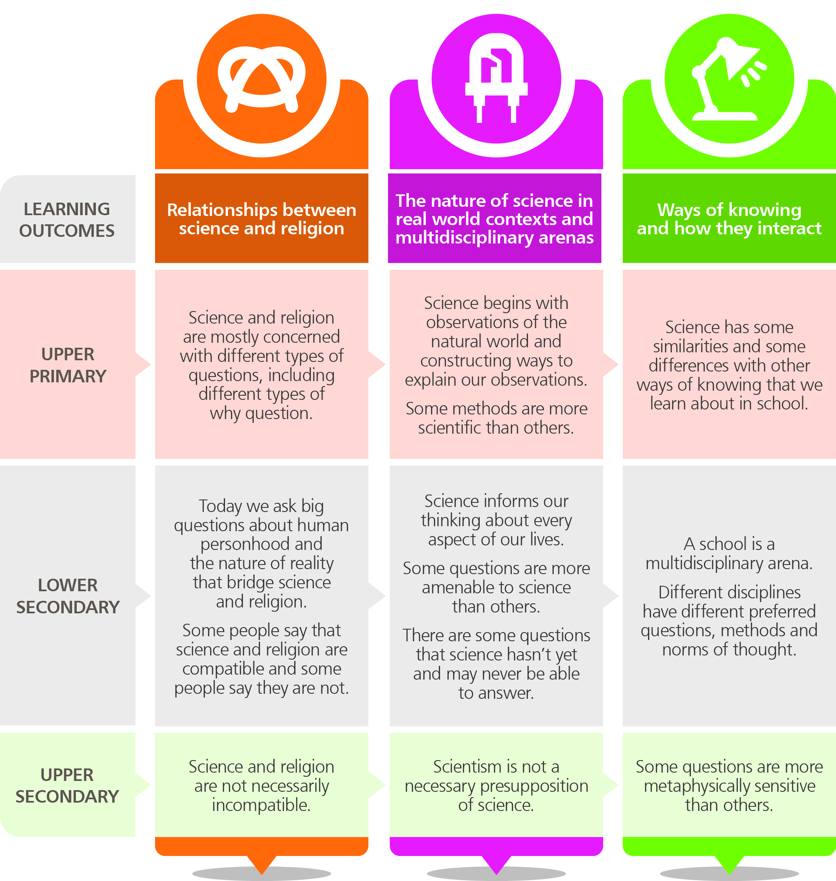

The resources for Year 7 and Year 8 are closely linked and address the following key learning outcomes from the Framework:

1. Science and religion are mostly concerned with different types of questions, including different types of why question

- Religious texts are written to present religious ideas not as alternatives to scientific descriptions
- Religious texts do tread on ground that science covers – by referring to how the universe began, even though this isn’t the primary purpose of the text.

2. Some people say that science and religion are compatible and some people say they are not

- People respond differently to religious creation stories, some seeing them as evidence of a conflict between science and religion and some referring to the poetic nature of the text, and the time when it was written, to explain why the accounts differ

3. Different disciplines have different questions, methods and norms of thought

- Religious ideas are supported by evidence that is often subjective, personal and tentative. One person may see the beauty of the universe as a reason to believe in God while another does not

4. Some questions are more amenable to science than others.

A note about Design/Intelligent Design

Design is a traditional belief by the Abrahamic faiths that we live in a purposeful universe created by God. What can be confusing is that there is a movement called ‘Intelligent Design’ which argues that some of the features of living things appeared miraculously in ways that cannot explained by science.
The distinction between Design and Intelligent Design may be too subtle for most students but as an analogy if you woke one morning to see a cup of hot chocolate by your bed, you might assume that a parent had put it there. That kind of thinking fits into the notion of Design. But if you decided that it had arrived by magic and that no other explanation will ever be found, that would be more like Intelligent Design. The vast majority of scientists (religious and not) are opposed to Intelligent Design.

Session 1: The Creation Sleuths
Resources
Title | Type
The Creation Sleuths | Website pages
Creation | Teachers’ PowerPoint (from website)
Detective Sheet 1a: Creation sleuths | worksheet
Detective sheet 1b: Sleuths at work | Worksheet
Homework Sheet 1c: My favourite meal | Homework sheet
Ard Louis: Why a scientist reads the Bible | Video on website
Dr Rowan Williams: Did Adam and Eve exist? | Video on website
Dr Rowan Williams: Why read the Bible? | Video on website

Overview
In this session students compare the Big Bang theory with the Biblical Creation story and consider whether to accept science-only, religion-only or open-to-both.
Teaching Points
The three approaches described here are a huge simplification of the range of approaches people take when comparing science and religion.
‘Open to both’ as described here is not the same as unsure. ‘Open to both’ is the idea that science can tell us how the universe works while religion addresses different types of questions such as how people should behave and why God intended a Universe to exist.
It may look as though a lot of class time is going to be spent explaining one particular perspective. On the other hand, this perspective is the one adopted by the majority of faiths today and also by scientists who believe in God. It is also the most difficult perspective to grasp of the three described here because it means looking at the language and purposes of Creation stories and science.
Pupils could be told that it is important, whatever perspective they choose to take, to have some understanding of the other approaches.
Lesson objectives
Most students should be able to:
- Know that there is a Creation story shared by Christians, Jews and Muslims.
- Compare this Creation story with the story from science, identifying key differences and similarities.
- Understand what the term Creation means in religious thinking (theology).
- Explain that there are three stances people take regarding Creation stories: some accept only religion, some accept only science and some are open to both science and religion.
- Explain that those who interpret Creation stories as allegorical say it is useful to think about the message and writing style of the text and the audience they were written for.

Specification
Objectives:
- Pupils should learn that truth is interpreted in different ways, each of which may be valid.
Outcomes:
- read biblical text with understanding

Keywords
Creation story, the Big Bang theory

Lesson Outline
Starter
Ask students to imagine that the school day today will be given over to an ‘egg theme’. Eggs will be the subject of study in English, History, Art, Music ... ask pupils to come up with a way that the egg will be studied in each subject area (for example, in Art pupils might draw eggs and study their shapes.)
Ask students whether the ideas covered in each lesson (Art, science, music…) is conflicting or complementary – does it contradict itself or does it add up to a bigger picture. Explain that this is how some people see the relationship between science and religion – and now we will find out more.
Main Activities
Activity 1: Creation and the Big Bang theory
Resources: Teachers’ Whiteboard PowerPoint ‘Creation-v2’ and Worksheet sheet 1a for pupils
[slides 2 – 4] Long ago, people in China and India were told that the Earth came from a Cosmic Egg. They had no reason to doubt this, did they believe it? (Yes) But why did they have this story – was it for scientific interest or did it serve a different purpose. (It explained why people existed and their relationship with the world).
[slides 5] There are three approaches people take when they think about what to believe from science and religion, science only, religion only and open to both.
Pause for pupils to put their first ideas about how these views might work onto worksheet 1a.

Activity 2: Creation and the Big Bang theory
Resources: Worksheet sheet 1b for pupils
Provide pupils with a Biblical and Scientific account of origins of universe, side by side (for example as provided on worksheet 1b).
Can pupils:
- suggest differences
- suggest similarities
- suggest the purpose of each account?

Activity 3: The Creation Sleuths
Resources: The website – to note the Creation sleuths and Teachers’ Whiteboard PowerPoint ‘Creation-v2’
Show students the ‘Creation sleuths’ pages of the website
The Creation Sleuths
Take students quickly through the pages to highlight the main ideas. Tell students they will be looking again for homework and that the last page has a homework activity and a drag-and-drop game for revision. The homework activity is described shortly.
Dr Ard Louis (in the video clip) is a theoretical physicist at Oxford University.
Then move to the PPt [slides 6-17] The sleuths present the arguments that are also on the website. The slides can be changed to suit your needs.
Activity 4: Reading the Label
Resources: packages and tins with labels.
One of the points made on the website and in the PowerPoint is that religious texts sometimes use metaphors and styles of language that were suited to their own times of writing.
Give small groups of pupils one or two food packages to look at. Ask them to write down three things that the label tells them. Ask them now to imagine that the package has fallen into the hands of a person living over 2000 years ago. Ask them to explain those three pieces of information in a way that this person will understand.
Plenary
Are pupils beginning to understand why people disagree about whether religious and scientific views of universe are compatible?
Do pupils understand the three sides of the argument?
Open to both Science and Creation stories have different aims. They are worth keeping because they each tell us something important
Science only We don’t need religion any more or the religious story is too incredible to accept.
Religion only The words of Creation stories carry both religious and scientific descriptions and should be given precedence over direct observations.

Additional Resources
There are two further videos in this section of the website which you may want to show students. They are responses recorded with Dr Rowan Williams about how he understands the Creation story in the Bible and why he studies the Bible today – in an age of science.
Homework
Pupils could review the main ideas by visiting the website and working through the ‘Creation sleuths’ pages.
Pupils could do the homework suggested on the website which is to write two pieces of writing that use different literary styles. Students do not need to access the site and can instead be guided by Homework sheet 2c.

Detective Sheet 1a: Creation Sleuths
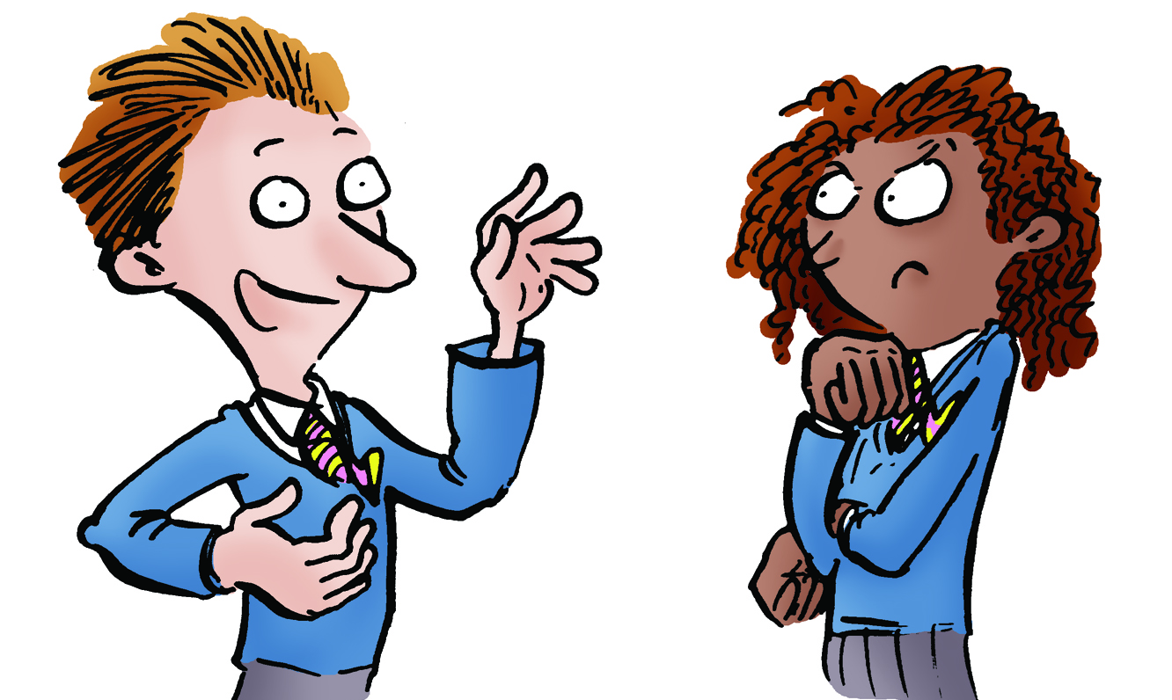 | “Here’s what I don’t get. If the Bible is meant to be a good source of truth, why say the Universe got here in six days when it was really billions of years?”  “Maybe it was a typo. Instead of 6 days they meant to say 14 billion years ... hmm, major typo.”  “It can’t be a typo – or surely it would have been corrected by now. There must be another explanation – but what?

Talking Point:
How do you make sense of the scientific and religious accounts of how the Universe began?

Key ideas
- People respond in different ways to the ideas that come to us from science and religion. These ways are
1) Religion only: the view that religion tells us everything we need to know
2) Science only: the view that we don’t need the ideas from religion now that we have science
3) Open to both: the view that science and religion, taken together, provide a bigger picture.

Now try this:
Can you think of an argument that someone with each of these perspectives would give when presenting his or her view? Fill in your ideas on this table.
View | An argument that someone with this view might give for why he or she is right | My view about this idea
Science only
Religion only
Open to both

Mission accomplished:
- I can explain three ways that people think about the ideas we have from science and religion and can give an argument for each.
- I can give my view about how I understand the ideas from science and religion.
Detective Sheet 1b: Sleuths at work
  Here is how the Bible describes Creation:
  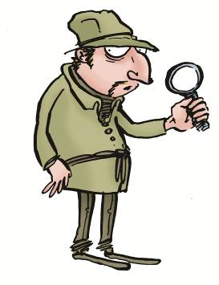
  “First God made heaven & earth. The earth was without form and void, and darkness was upon the face of the deep; and the Spirit of God was moving over the face of the waters. And God said, "Let there be light"; and there was light…..” Genesis 1:1-31
  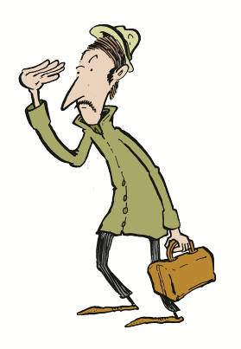
  Here is a description from science of the origins of the Universe:
  The theory about origins that has the most support from scientists is the ‘Big Bang theory’. This says that time and space began 13,700,000 years ago. The Big Bang theory is supported by observations of space today. Scientists say that these observations are clues to what happened in the past.

Fill in the table to compare the Bible and Science on this topic.
 | Bible account | Scientific account
When was it written and who for?
What does the writer think the reader needs to know – why was it written?
What kind of wording is used (poetic, factual, jokey)?
In 3000 years, what will people think about this text as a source of religious or scientific truth?

Dr Ard Louis is a scientist at Oxford University who believes in God. He says that Creation stories are not trying to present a kind of scientific truth. What do you think about this view?

1c: Homework - My Favourite Meal

Imagine that you are the celebrity guest at a poetry festival. You've been asked to open the festival by reading out a poem that you yourself have written. The topic is "My favourite meal." The word limit is 50 words. Write the poem that you will read out on the day.
Now imagine you are the celebrity guest appearing on a cookery show. The host of the show is a chef. He says he will cook your favourite meal for you. Before the show he asks you to send him details to help him to make it just the way you like it. Please write him an email. The subject line should say: "My favourite meal."

Compare these two pieces of writing. What are their purposes and how are they different. How does this help you to think about the different types of writing in the Bible and in a science text book?

Suppose you stand up to read your poem at the Poetry Festival, only to discover that you have printed out your email and not your poem. Describe how you feel and how you try to rescue the situation on the day.

Session 2: Different Types of Questions
Resources
Title | Type
Different Types of Questions | webpages
Different Types of Questions | Teachers’ PowerPoint
The Big Bang Theory | Teachers’ PowerPoint (if you choose to cover the science)
Detective Sheet 2a: What’s the difference between a scientific idea and a religious idea? | Worksheet
Detective Sheet 2b: Tools of Enquiry | Worksheet
Homework 2c | Homework sheet
How do we know what we know? | Video
Sweets experiment | Video
A science question | Video
Prof Colin Humphreys - Can you prove God exists | Video

Overview
This session looks at the types of questions that science can and cannot address. It might be useful to give students three classifications – questions science can answer now, questions it cannot answer yet and questions it cannot address. The session concludes that it is beyond the capability of science to test whether God exists.
The key idea for students is that science and religion are mostly concerned with different kinds of questions.

Lesson objectives
Most students should be able to:
- Be aware that some scientists believe in God and some do not.
- Classify questions as scientific, historical, religious ...
- Understand that creation stories were not written to answer scientific questions.

Related science objectives
Students should be able to:
- Explain how the Big Bang theory is supported by observations of space today.
- Understand that scientific theories can be revised if new evidence or a better theory is produced.

Specification
Objectives:
- Pupils should learn that truth is interpreted in different ways, each of which may be valid.
Outcomes:
- describe different types of truth;
- explain what is meant by religious truth;

Keywords
Scientific enquiry, idea, theory, evidence, creation, observation, fact, belief, opinion, Big Bang theory,

Lesson Outline
Starter
Resources: Raisin Ballet and Worksheet sheet 2a for pupils
Show students the raisin ballet video on the website – and/or try the experiment with them. A handful of raisins are dropped into lemonade. Diet lemonade and large dry raisins work best.
Ask students to make observations and construct a theory about ‘why the raisins dance’
Notice with students that this is a ‘science investigation’ because we are trying to understand how something in nature works and we are drawing on observations to support a theory.
Students could be given Worksheet 2a and could return to this periodically during the lesson.

Activity 1: Different Types of Questions
Resources: Worksheet sheet 2b for pupils
Play the video on the website, A science question Give pupils a set of questions to sort into scientific, historical and religious (Worksheet 2b).
Activity 2: Pinning Science Down
Resources: Teachers’ Powerpoint for Whiteboard
The slides in the PowerPoint explain the nature of science using the example of an investigation to discover what kinds of sweets produce the most froth when they are dropped into diet coke. This investigation could also be conducted in a joint science-RE lesson. If the investigation is carried out, pupils should be told how to ensure the experiment is safe. The students on the video have eye protection and keep their faces away from the bottle.

Plenary
Resources: Reasons in Religion – video of Professor Colin Humphreys
Professor Sir Colin Humphreys was knighted for his services to science and runs a Materials Lab at Cambridge University. He Is a Christian and in this video he explains why he believes that God exists.
Homework/further research
Pupils could visit the website to read and consolidate the ideas from the session.
Pupils could be given the Homework sheet (2c). This accompanies a video on the website, ‘Raisin Ballet’ for homework. The sheet asks pupils to watch a scientific experiment and to draw on observations to explain what is happening. Pupils are then asked to think about the purpose of a Creation story. Pupils could also use the website to review the ideas covered in the session.

Answers
Worksheet 2b Sorting questions
Many of the questions here (and in life) are ambiguous and can be fitted into other categories depending on how they are interpreted. Accept other categorisations if pupils can give a good explanation for their choices.
Literature
Why did women authors write under male pseudonyms
Are happy story endings better than sad ones?
Why didn’t Harry Potter use his magic powers to take revenge on the Dursleys?
How many lines does a sonnet have?
What is the world’s best book?
History (and politics)
What makes a good government?
Why did the War of the Roses happen?
Do world leaders have any friends?
Is trial by jury the best way to judge someone?
Did King Alfred really burn some cakes?
Science (and engineering)
Why are arches important in architecture? [science and/or history]
Why do four legged tables sometimes wobble?
How are planets different from stars?
Why do we have seasons?
What causes meteor showers?
Why is the sky dark at night?
Geography
What is a tectonic plate?
Where is the north pole?
How deep is the deepest ocean?
How can we measure the speed of coastal erosion?
Religious questions
Which religions have Adam and Eve in their Creation story?
What was the role of the Rainbow Snake in the religious stories of Aboriginal Australians?
Why is Pandora’s box important in Greek mythology?
The Khanda is a symbol in Sikhism. What does this symbol represent?
Who is Jesus, according to Christians?

Homework sheet (Raisin Ballet)
The raisins are rising because air bubbles from the lemonade gather on the raisins. That lifts them up to the surface but there, the bubbles pop. The raisin flips over, because it has bubbles on its underside. Those bubbles pop and the raisin falls

Detective Sheet 2a: Science and Religion and the Questions they address
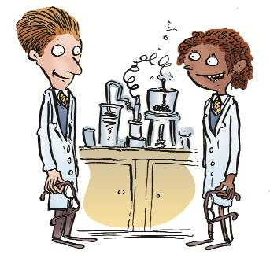 | “The best bit about science is the experiments”  “I know, we should do experiments in all our lessons – everyday all day. Only experiments!”  “Er – yeah, but I think then every lesson would be a science lesson … wouldn’t it? What about the other subjects, we need them too.”
Key Ideas
Scientific investigations are investigations that are designed to find out how the world works. Scientists come up with ideas which can be tested by making observations. We call the ideas, ‘theories’ and the observations that support the theories, ‘evidence’.

Talking Point:
- Most people can recognise a ‘science question’ when they hear one but can you think of some questions that are not science questions?

Now try this
Think of an idea that can be tested using a scientific investigation. What is your idea, and how would you test it? There are some words to start you thinking below.

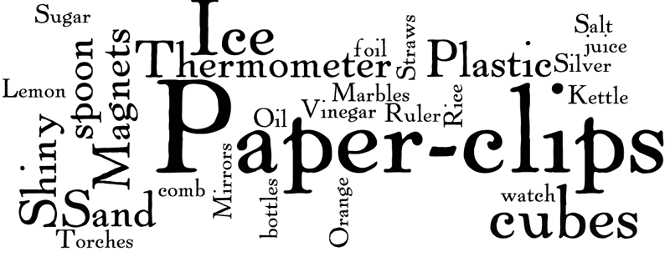

Mission Accomplished
- Give an example of a question that can be tested by making observations
- Give an example of a question that cannot be answered by a scientific enquiry
Detective Sheet 2b: Tools of Enquiry
1) The question, “When was the battle of Hastings?” is a history question. What about the questions below, what kinds of questions are they? Mark each one with the appropriate letter to show your idea of the kind of question it is. Be ready to explain your choices as opinions can differ!
Literacy = L, History = H, Religion=R, Science =S, Geography = G
  - Did Harry Potter use magic on the Dursleys?
  - What makes a good government?
  - Why did the War of the Roses happen?
  - Why is Pandora’s box important in Greek mythology?
  - How deep is the deepest ocean?
  - What is the most interesting book?
  - Did King Alfred really burn some cakes?
  - Are happy story endings better than sad ones?
  - What is the carbon 14 dating method?
  - Which religions have Adam and Eve in their Creation story?
  - Where is the north pole?
  - Why are arches important in architecture?
  - How many lines does a sonnet have?
  - Is trial by jury the fairest way to judge someone?
  - Why do four-legged tables sometimes wobble?
  - What causes meteor showers?
  - The Khanda is a symbol in Sikhism. What does this symbol represent?
  - Why is the sky dark at night?
  - Who is Jesus, according to Christians?
  - Do world leaders have any friends?
  - What do Aboriginal Australians say was the role of the Rainbow Snake?
  - What is a tectonic plate?
  - How can we measure the speed of coastal erosion?
  - How are planets different from stars?
  - Why did women authors write under male pseudonyms
  - Why do we have seasons?

Detective Sheet 2c (homework)
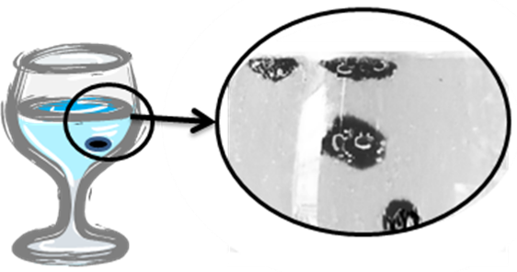 | When raisins are dropped into a glass of lemonade they fall to the bottom and then, mysteriously, they rise. Then they fall, then rise then fall...  You can see this for yourself. Visit Raisin Ballet -

What’s going on?
- What is carrying the raisins up to the surface? (look at the picture).
- What happens when the raisins get to the top and why?
- What do the raisins do then?
- So putting this all together, why do the raisins go up and down?

Explanations
- The explanation you’ve just given is a scientific explanation. It explains what causes the raisins to go up and down. When you look at Creation stories, you are seeing an explanation written by people thousands of years ago. If you look at it as a scientific explanation, you will see that it is very puzzling indeed. But it is not for scientific reasons that it is important to religious people So why is it important to religious people?
I think the story of Creation is important for religious people because ...

Session 3: Noah’s ark
Resources
Title | Type
Noah’s ark | Session guide
Noah’s ark | Teachers’ PowerPoint (from website)
Detective Sheet 3a: Is the story of Noah’s ark true? | worksheet
Detective sheet 3b: Help us out here | Worksheet
Noah’s ark: Myth Legend or Reality? | Article by an expert for pupils
The geological evidence for a flood | Video on website

Overview
Students consider different ways to interpret the story of Noah’s ark. They notice that ‘science questions’ such as did the flood take place are easier to address than ‘religious questions’ such as what messages should be understood from the story.

Teachers’ notes
This is an opportunity to introduce to pupils the idea that religious texts can include many different literature genres – and to introduce the term literature genre to pupils. There are over 40 different literary genres in the Bible including poetry, prose, elevated prose (in the early chapters of Genesis) letters, irony ... and so on.

Lesson objectives
Most students should be able to:
- Know that there is a story shared by Christians, Jews and Muslims about a Great Flood (Noah’s ark).
- Understand that people take different perspectives when they read this story: Some see it as a worldwide happening and some see it as more localised; some see it as an exaggerated story which is primarily a message, Some reject it altogether
- Explain that when reading a text it is useful to think about the message and writing style of the text and the audience it was written for.

Learning Objectives
Objectives:
- Pupils should learn that religious texts are often interpreted in different ways by people with different starting positions.
Outcomes:
- read biblical text with understanding

Keywords
Flood, ark, analogy, exaggeration, myth, fable, evidence, scientific enquiry, atheist, agnostic, literalist, Christian, Theologian. Geologist.
Lesson Outline
Starter
Pupils could collectively recall what they know about the Noah’s ark story and consider how an atheist, an agonistic and a Christian might respond to the story. Would all Christians respond the same way or might they have different views?
Brainstorm with pupils the meanings of the following terms that may be useful for the lesson – atheist, agnostic, literalist, Christian, Theologian. Geologist.
Return to the story of Noah’s ark to identify a number of different perspectives that someone might take: Pupils could come up with their own list of different perspective on whether the story of Noah’s ark is true or you could guide them towards these options:
- A literal reading of the story
- The idea that the story has some truth which has been exaggerated
- The idea that the story is fiction, like a parable, to give readers a message.
- An outright rejection of the story on the basis it has no value.

Main activities
What does a Geologist say?
Resources: Video of Denise Balmer on the website - Is Noah's Ark story true? . Article by Denise Balmer and worksheet sheet 3a for pupils
The class could watch the video on the ‘Noah’s ark’ page of the site in which geologist, Denise Balmer explains to Year 7 at Trevelyan school the geological evidence for the ‘Great Flood’.
Ask pupils how they respond to Denise Balmer’s arguments.
Give pupils Worksheet 3a and also a copy (between two) of the article by Denise Balmer. Ask pupils to address the questions on the sheet. The last question asks students why Denise Balmer focuses on ‘science questions’ in her article.
Conclude for pupils that this highlights the difference between scientific and religious ways of thinking. In this lesson we have focussed so far on the types of questions that science can help with – particularly did a flood take place.
Religion is concerned not so much with whether the flood happened but with what this story is saying about God and his relationship with his people. That’s a much more challenging type of question to investigate because it is not so readily apparent how we might draw conclusions. The methods of science cannot help.

Play
Working in small groups, pupils could produce a scripted play to show the way in which the writer of the story developed the text. One pupil (in the group) would be Noah and the others would be advisors, relatives, God ... and so on. Through their presentation pupils convey (1) the meanings that they think the writer is giving us through the story and (2) how they see the text in terms of artistic license, revelation and factual reporting.

Plenary – a Debate
Pupils could suggest questions that would be good ones to debate, relating to the story. Pupils could select which questions to debate and could be put into small groups with one side in each group. The format of the debate is to be that each side makes three points and supports those points with reasons.
Pupils listening to the presentations could be asked to score them according to the following criteria:
- How persuasive was the presentation?
- Was the argument clear and easy to understand?
- How well was each idea supported with a reason or another form of argument such as a piece of evidence?

Extension: Investigating religious questions
This is likely to be as much as pupils can take in. It is for you to decide whether you want pupils to consider the religious questions provoked by the story and whether and how they can be investigated. If you do these notes may be useful:
The question that surely everyone would most like answered is – Is there a god and did he speak to Noah. That question is beyond any obvious means to answer.
Another religious question – and one that is more open to investigation - is why was the story told in this form at that time? Why did people at that time want the story to be heard?
Pupils may be interested to know that some of the methods that theologians use to address this question are the methods of history - to try to find out as much as they can about the people at that time. They want to know what the Hebrews believed and also how their beliefs compare with other communities around them.
This is because many of the religious stories that are treasured by religious communities mark a jump in how a people are seeing the world and/or the nature of their god. Thus the Bible describes the journey of a people who are trying to understand themselves and their Creator better.

Homework
Pupils could be given a set of key words for the unit and could produce definitions and examples to show their understanding of the terms.
Or give small groups of pupils other passages with a message about the nature of God to discuss and report on for the class. Tell pupils that the Israelites were surrounded by other communities who believed in different gods. They should try to think what messages the Israelites might have wanted to say, using these passages about ‘their god’.
- Potter in Jeremiah 18:6: ‘Like clay in the hand of the potter, so you are in my hand, O house of Israel.’
- Gardener in Genesis 2:8: ‘Now the Lord God had planted a garden in the east.’
- Architect and builder in Job 38:4: ‘Where were you when I laid the earth’s foundation? Who stretched a measuring line across it? On what were its footings set, or who laid its cornerstone?’

Detective Sheet 3a: Is the story of Noah’s ark true?

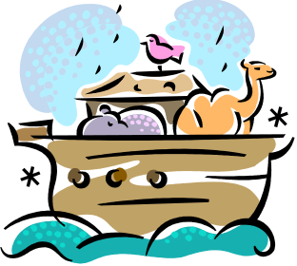 | “You’ve heard the story, you’ve seen all the cute pictures ... now it’s time for a reality check! Is the story of Noah’s ark true?”

Independent research; you will need the article by Denise Balmer for this task

1. In her article, Denise Balmer says:

It is possible that one man and his family lived and worked on the river and were able to get into a boat and save themselves; it is also likely that it rained for a long time;

Look through the article and find the reasons that the writer, Denis Balmer gives for the claims here.
- Why can we believe that one family were able to get into a boat?
- Why can we believe that it rained for a long time in this area?

2. Denise Balmer is a scientist and she says she believes that a flood may well have happened on the basis of the evidence she has researched. What kind of flooding does she suggest this was and what scientific evidence does she present to support her case?

3. Do you agree with Denise Balmer’s idea that the Flood happened but the size of the flood was exaggerated? Why or why not?

4. More challenging:

In her article Denise Balmer considers whether or not a flood happened at the time the story suggests and also at whether a family could escape in a boat.

Another important question is surely what the story is meant to tell us about God. Why, for example, did God only speak to Noah about the flood?

To what extent does Denise Balmer address these questions? To find out, use two coloured pens to mark the story and show where the writer is talking about scientific ideas and where she is talking about religious ideas. Why do you think Denise Balmer concentrates on the science questions arising from the story?

Noah’s ark –  Myth, Legend or Reality?  By Denise Balmer (geologist) | 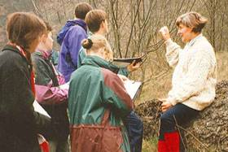  Denise Balmer with students on a geology expedition

As a child I heard the Old Testament stories at home and Sunday School and many of them conjured up pictures in my imagination. These images remained with me long after my childhood and into the days when I began to question everything, not just biblical stories but also various myths and legends, initially from the south west of England where I grew up. King Arthur and his Round Table, Alfred burning the cakes, and then also the local sayings, eg ‘red sky at night is a shepherd’s delight, red sky in the morning is a shepherd’s warning’ along with the myriad other age old country proverbs. What, you might ask, have all these things in common, or to do with the Old Testament. Let me explain how I see it:
Who writes history?
History consists of the memories of events, recorded by people who were present at an event, or who were in the vicinity at the time. However, often the eye-witnesses (people who actually saw the event) were not able to write (and so could not record on paper) the event and told the event to their peers and offspring.
This was repeated later, with embellishments, and some original facts were forgotten, while other points were added to enhance the story and make it more interesting for the audience. All cultures have stories of this kind, the majority with a large amount of traceable evidence hidden between the lines of the current story. For example, Robin Hood was a well known character around whom many stories and legends have been woven. He is an historical figure but much that we learn about him has been woven into his story to make him more like people’s ideas of a hero, - just go to Wikipedia to see how the stories have developed!
The story of the Great Flood – true but exaggerated
What then can we say about the story of the Great Flood? We believe the area of land inhabited by these ancient tribes was on the great plain between the Tigris and Euphrates rivers. In a year of exceptional rainfall both rivers flooded simultaneously. For local tribes, it would seem as if the whole world had flooded – the ‘world’ they knew could only have been as far as they could walk or travel by camel. River floods can come very quickly. Even today with our sophisticated communication systems, people are caught out and drown. How much worse it would have been for a primitive society.
I don’t have any problem with believing the basic story of Noah’s ark as it seems typical of the stories we remember when disasters happen. Think of current areas of the world that have experienced record rainfall and flooding. When these extraordinary event occur we hear about people being rescued from the sky, a woman giving birth in a tree, etc etc etc, all these stories are today documented with film and video. So why could this not have happened in Biblical times, with stories of heroism and the saving of creatures being chronicled and told to survivors, who were very few in number, and who were ready to believe that some Higher Being had brought judgment on a group of people who were living immorally, especially since they had escaped from the Flood.
It is possible that one man and his family lived and worked on the river and were able to get into a boat and save themselves; it is also likely that it rained for a long time. The story of a great flood is believable, but can we find evidence for it?
The evidence
If we look at some of the Old Testament stories, we read, for example that the River Nile flooded every year and it still does - or it did until people started tampering with its flow, and putting in dams and aqueducts. From general geography we know any large river flooding will spread fertile silt over the land beside its banks, which can be used to grow good supplies of cereal and other foodstuffs. This occurs today along many rivers and the nearby inhabitants take full advantage of this. So we have evidence to say that floods happen regularly. What about a great flood? Is there evidence for that?
As a geologist, I know that flooding rivers bring large quantities of mud, silt and debris down their channels which they deposit over the land which is flooded. In geological times, layers can be seen in rocks which show catastrophic events such as inundations by flood water, so surely it would be possible to find the evidence for a Great Flood thousands of years ago. This is one kind of evidence we can look for.
Another kind of evidence has come to light from a new marine research team from Tel Aviv University working with another organisation, called, EcoOcean. They were exploring the sea floor and found that indeed a flood happened around the time Noah was living. From core samples, they saw that a flood broke through the natural barrier separating the Mediterranean Sea and the freshwater Black Sea, bringing with it seashells that only grow in a marine environment. There was no doubt that it was a fast flood -- one that covered an expanse four times the size of Israel. What about Noah, can we know if he was there? Floods leave marks in the geological record, but it is not to geology that we turn when we want to know the names of the people who were living there, but to historical documents.
To summarise
There are so many events recorded in the Old Testament which we need to discuss and think about so we can understand them historically, geologically and geographically. But this doesn’t mean that there is no truth in the Bible. Far from it, it just helps those of us with enquiring minds to wonder more at the wonderful planet on which we live, and appreciate that some Higher Presence is behind it all.

