Year 9 Unit: Do Science And Religion Agree?
Session | Title | Key ideas
9-1 | What is the “Conflict View” of the Science and Religion? | Many people think that science and religion must disagree, encouraged by the media.
9-2 | Dear Darwin | Darwin’s theory of evolution is not opposed in principle to religious faith.
9-3 | Different Views About Origins | Three of the main ways of understanding the creation/evolution debate.
9-4 | What’s the Point of God in Science? | If God is understood to be the uncaused Creator, who upholds and sustains the universe, there is no necessary conflict between science and faith.
9-5 | God and Miracles | Many reported miracles do break natural laws, but nonetheless are not incompatible with religious faith. There are scientists who believe in miracles.

Teacher Background

This unit is about the “Conflict View” of science and religion. Many people feel that there is a conflict between science and religion. The aim of this unit is to:

- Explain how the conflict view arose and why it gets so much attention

- Show that the conflict view is not the only view. There are many scientists who say that science and religion are compatible and complementary, and this perspective will be explored with reference to a number of key areas of the science-religion debate.

This resource and Key Stage 3

This resource offers a learning journey to take pupils from Year 7 to 11, captured in our Epistemic Insight Curriculum Framework on the next page:

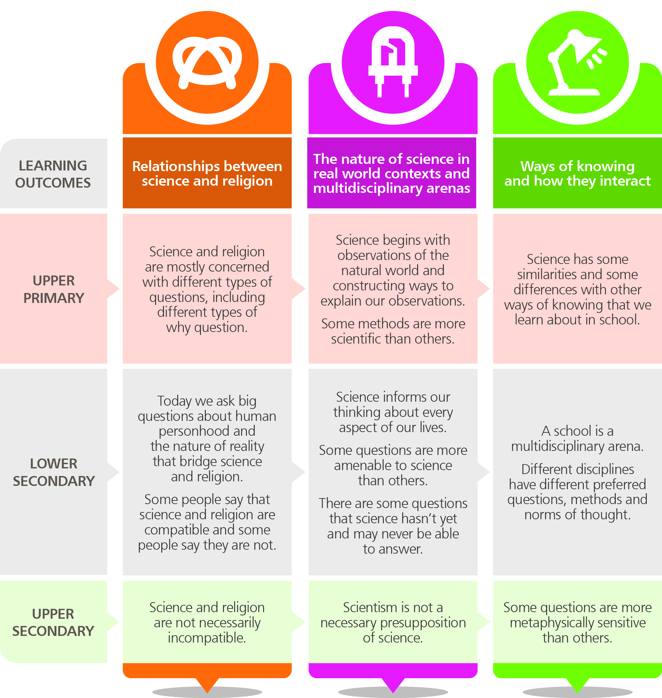

This year 9 unit is closely linked with the Year 7 and Year 8 units and address the following key learning outcomes from the Framework:

1. Some people say that science and religion are compatible and some people say they are not

- The available evidence can be interpreted as supporting either the existence or the absence of God

2. Different disciplines have different preferred questions, methods and norms of thought

- There are different ways of seeing things
- Evidence can be interpreted differently depending on perspective

3. Science has some similarities and some differences with other ways of knowing that we learn about in school

- All arguments require justification and explanation

Session 1:
What is the “Conflict View” of Science and Religion?
Resources
Title | Type
The Daredevil Gene  Are Science and Religion at War?  Exploration Sheet 1: Can Science and Religion Go Together? | Article and video (approx 1 min)  Video (approx 20 seconds)  Worksheet

Overview

This session explores the commonly held opinion that science and religion are in conflict, and looks at reasons why so many people believe this. It goes on to consider the role of the media in encouraging the conflict view, and sets out an alternative position, namely that science and religion are complementary.

Lesson objectives

Most students should be able to:
- Understand what the conflict view is
- Give reasons for why many people believe that science and religion are in conflict
- Explain that there are scientists who believe that science and religion are complementary, rather than conflicting

Some students should be able to:

- Explain the role of the media in fuelling the conflict view
- Evaluate some of the reasons religious scientists would give for believing that God and science go together

Related science objectives

Students should be able to:

- Understand what scientific methods are
- Understand that science has limits, and is a discrete field of enquiry

Keywords

science, religion, conflict view, complementarian view, ultimate questions

Lesson Outline

Homework, prior to lesson
The Daredevil Gene

Direct pupils to look at the “Daredevil Gene” on the Never Off Topic website and to watch the video on the page.

Instruct them to come in ready to discuss why the Daily Mail might prefer to suggest that risk-taking is “all in our genes”, rather than offering a more balanced picture.

Starter

Gather pupils’ responses to the Media’s coverage of the ‘Dare Devil gene’ (see above) and relate this example to the broader science-religion debate.

Play the “Are Science and Religion at War?” video on Never Off Topic website.

Repeat the activity shown in the video with your pupils. Discuss the question, with individuals from each group justifying their position.

After the discussion, find out whether anyone would want to change sides as a result of what they have heard.

Activity 1: Can Science and Religion Go Together?

Resources: exploration sheet 1, video on website

Hand out “Exploration Sheet 1”. Read together the quotes at the top, and then ask pupils in pairs to discuss the “For Discussion” questions. Talk about them as a whole class, and then have the students work on the “Sorting It Out” activity individually.

Watch the “The Big Questions of Life” video on the website. Discuss why there is sometimes conflict between science and religion.

Read and discuss together the “Making It Clear” information. Pupils could write down the key terms in bold, along with a definition, into their books.

Activity 2: Science, Religion and the Media

Ask the pupils where they think most people get their information from about science, religion and ultimate questions. Identify the media as a key source.

Ask the pupils to read the fictional newspaper articles on Exploration Sheet 2, and discuss in pairs which they think a newspaper would rather publish.

Develop into a whole class discussion, and draw out the idea that the media thrives on controversy and conflict, while harmony and co-operation do not tend to make good stories.

Pupils discuss which headlines would be good news stories, and which would not, and then try to write their own.

Conclude by summarising the impact of the media on the science-religion debate: a tendency towards emphasising conflict over cooperation.

Plenary

Put the following dialogue on the board -

Conflict Clare: I think that science and religion are at war. Every time science advances, religion takes a step back.
Complementary Chris: I disagree. I think that religion and science go together fine. If God is the creator of everything, then science is simply exploring what He has made, and how it all works!

Take suggestions from the class to continue the dialogue, trying to incorporate all the ideas from the session into the responses. Pupils could copy down the finished dialogue as a summary of what has been covered.

Homework/further research

Pupils could visit the website to read further and consolidate the ideas from the session.

They could research a current science-religion story in the news, and write a short summary of it, stating whether it supports the conflict or the complementary view of the relationships between the two.

Exploration Sheet 1:
Can Science and Religion Go Together?
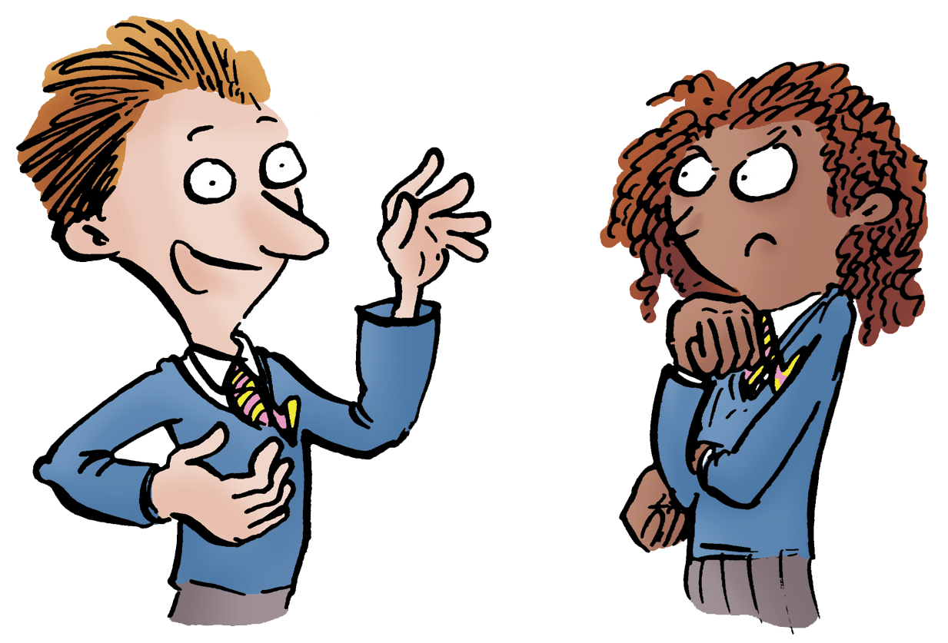 | “I don’t believe in evolution, because it’s not mentioned in scripture.”  “I think religion is rubbish because it doesn’t take account of modern science.”  “I want to know why I’m here, but I’m not sure whether I should trust science or religion to tell me the answer.”
1. For Discussion
Can you think of two questions which could have either a scientific or a religious answer?
How can people decide whether to answer these questions using scientific or religious teaching?
2. Sorting It Out
What answers do you think science and religion would give to the following questions?
Question | Scientific Answer | Religious Answer
Why are we here?

Is evolution true?

How did the universe begin?

What happens when we die?

Add your own…

3. Making It Clear
The “big questions” discussed in the video and listed above can also be called ultimate questions. These are questions which do not have factual, straightforward answers.

The idea that you can give ONLY scientific OR religious answers to ultimate questions is called the “conflict view”. It says that science and religion are in conflict, because only one can be right.

Many people disagree with the conflict view, however, and argue that the “big questions” need to be understood from BOTH a scientific AND a religious point of view. They say that science and religion go together – they are complementary. This is called the “complementarian view”.
4. Bringing It Together
Discuss with a partner how someone who was both religious and a scientist might answer the questions above.
Summary
I know what ultimate questions are, and I can give an example of one
I know why some people think science and religion give conflicting answers to ultimate questions
I know why other people think that the answers given by science and religion are complementary

Exploration Sheet 2: Science, Religion and the Media
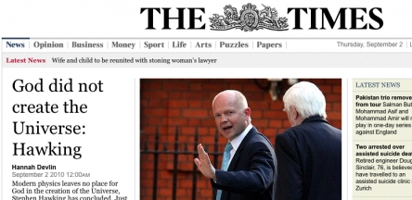

1) Read the two stories below, and discuss which a newspaper would rather publish

A. Religion Staggers Under Scientific Onslaught

Two extraordinary scientific discoveries in the last 150 years have gone a long way towards destroying belief in God. The publication in 1859 of Charles Darwin’s “On The Origin Of Species” has shown how life developed without the guidance of a higher power. In 1964 the discovery of background cosmic radiation throughout the universe provided firm proof for the Big Bang theory, which has shown how matter came into existence, so now we can do away with the concept that God was necessary to get the universe going. It’s a battle between certainty and superstition, between knowledge and blind faith – and religion is close to surrender.

B. Science And Religion Getting On Fine

Dramatic scientific discoveries during the past 150 years have been widely accepted by many of the world’s faith communities. A large number of prominent Christian leaders and clergymen, for example, have hailed Darwin’s theory of evolution as a work of genius which shines a brighter light on God’s means of creating life. And lots of them are equally enthusiastic about the Big Bang, seeing it as the scientific counterpart to the creation stories in Genesis chapters 1 and 2. As our understanding of the world continues to develop, science and religion are getting along just fine.

2) Discuss which of the headlines about science and religion in the table below would make good media stories, and which would not.

Discovery Of New Particle Leaves No Room For God | Dawkins: Science Has Disproved Religion
Survey - 40% of Scientists Believe In God | Discovery Of Alien Life Bewilders Church
Any Evidence For God? “No” Says Scientist | It IS Reasonable To Believe In God

3) Try writing your own “science and religion” headlines about famous scientific theories, e.g. evolution, or the Big Bang.

Session 2: Dear Darwin
Resources
Dear Darwin  Background to the Great Debate  The Great Debate  Interview with the Film Director | Video (approx 30 minutes)  Word document  Play script – Word document  Text of interview

Overview

This session aims to inform pupils about the context in which Darwin put forward the theory of evolution. It explains that Darwin himself did not see evolution as opposed to Christianity, and that the theory was both supported and opposed by religious and non-religious people at the time.

Lesson objectives

Most students should be able to:

- Understand the background to the publication of On The Origin of Species
- Understand the different reactions to the theory, including Darwin’s own mixed feelings
- Explain why many religious believers were happy to accept evolution

Some students should be able to:

- Summarise and evaluate the positions of Huxley and Wilberforce at the 1860 Oxford debate

Related science objectives

Students should be able to:

- Assess the current scientific understanding of the evidence for evolution

Keywords

evolution; Darwin; Galapagos Islands; natural selection; the Oxford Debate; Wilberforce; Huxley

Lesson Outline

Starter

Brainstorm on the board everything members of the class know about Darwin. Try to draw out his approximate dates, that he was the author of On The Origin of Species, and perhaps raise the question of his religious convictions. Does anyone in the class know what he believed about God?

Follow up with a discussion of what the class think Darwin himself would make of the impact of his ideas on the world since his death. Would be approve? What would you ask him if he were still alive?

Activity: Darwin, Evolution and Faith

Resources: Never off Topic website, Exploration Sheet 3

Show class the video “Dear Darwin” from the website (approx 30 minutes). Pupils fill in gaps on Exploration Sheet 3 as they watch.

Discuss any issues arising from the video. Are pupils surprised by the reaction to On The Origin Of Species? What do they know about the current understanding of the evidence for evolution? What do they make of Darwin’s own position with regard to religious faith?

Activity: The Oxford Debate Re-enacted

Resources: “Background to the Great Debate” summary, and “The Great Debate” script (both from website)

Hand out copies of “Background to the Great Debate”. Pupils read through the information, and identify the five most important facts in the text. Ask individuals to name one of their most important, justifying its selection.

Hand out copies of “The Great Debate” script. Assign parts, and put on the play.

Discuss the play afterwards, focussing on why the pupils think this event has become so well known, even though we can’t be absolutely sure what was said, and Darwin wasn’t even there. Link to the tendency of history and the media to focus on the sensational and the confrontational.

Plenary

Have the students write a 150 word epitaph for Darwin, perhaps to go on his gravestone. Read a few out and vote on the best.

Homework/further research

Pupils could visit the website to read and consolidate the ideas from the session, including the “Interview with the Film Director.”

They could write their own letter to Darwin, expressing their views about his theory, and offering their thoughts on its impact since his death.

Pupils could then swap letters, and write a response to someone else’s letter on Darwin’s behalf.

Exploration Sheet 3: Darwin, Evolution and Faith

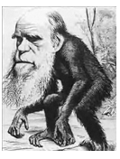
Watch the “Dear Darwin” video and fill in the blanks in the sentences below as you go along.

1) In 1859 Darwin published On The Origin of Species in which he put forward the theory of ____________________.
2) Darwin’s theory was based on observations he made during his voyage around South America between 1831 and 1836 on the ____________________, and on which he struggled throughout with seasickness.
3) Much of Darwin’s key evidence was gathered on the ____________________ Islands, and his big idea was partly based on the evolutionary theory of his grandfather, Erasmus Darwin.
4) Darwin discovered not only finches on the Galapagos, but also ____________________, many of which he ate. His most important insight, despite this, was that particular species were specially adapted to their specific environments on the different islands, the result of generations of natural selection.
5) Darwin was pushed into early ____________________ of his book because a rival scientist, Wallace, was about to publish on the same topic, and he was urged by his friends Hooker and Huxley.
6) Darwin’s beloved daughter ____________________ died as a child, which greatly affected Darwin’s religious faith, though he never became a committed atheist.
7) The ____________________ did not take any definite position against evolution.
8) The famous debate between Samuel Wilberforce and Thomas Huxley was on 30th June _______ at the annual meeting of the British Association for the Advancement of Science in the Oxford University Museum. Darwin himself was not there.
9) Darwin’s faith was destroyed by his daughter’s death, but he never became anti-_____________. Many strong religious believers, and many ministers of the church, welcomed Darwinism.
10) History and the media have tended to simplify the issues surrounding evolution. For example, Darwin taught that humans and apes have a ______________ ______________, whereas many people today believe he claimed that we are descended from apes.
11) The sensational controversy in Darwin’s time was that he had claimed “man is an _________”.
12) There are four main ways of responding to evolution:
a) ____________________: No evolution, God created life literally as it says in the Bible
b) _______________ _____________: Alongside evolution, God does special acts of creation
c) _______________ _____________: Evolution is God’s way of creating life
d) _______________ _____________: Evolution created life and there is no God

Session 3: Different Views About Origins

Resources
Title | Type
Genesis 1-2  Yr9-Whiteboard-origins  The Big Questions Of Life, The Universe and Everything  Science tells you how, religion tells you why ...  Your quick guide to Creationism, atheism and theistic evolution | Bible text  Whiteboard powerpoint  Video (approx 5 mins)  Video (2 minutes)  Video (1 minute 40 secs)

Overview

This session aims to develop the pupils’ understanding of three main approaches to the interpretation of Genesis and understanding of our origins. It begins to establish the ‘how and why’ argument which is developed further in the Year 10-11 materials.

Lesson Objectives

Most students should be able to:

- Name and define three approaches to origins
- Explain which they find most convincing
- Distinguish a literal interpretation of Genesis from a figurative one

Some students should be able to:

- Assess the strengths and weaknesses of each of the approaches

Keywords

Young Earth Creationism; Atheistic Evolution; Theistic Evolution; Genesis; revelation; literal; figurative

Lesson Outline

Starter

View with pupils the PowerPoint, ‘Origins’. Ask for their responses to Denis Alexander’s viewpoint (second to last slide). Ask pupils whether they think Denis Alexander understands the Genesis Creation story literally or figuratively,

Read aloud, or listen to, Genesis chapter 1 verse 1 through to chapter 2 verse 2. Have students keep a tally of the number of times the following words or phrases appear: “God”, “Let there be”, “good”, “and there was evening, and there was morning”, “evolution”.

Discuss what sort of text this is: poetry, history, science, journalism, something else entirely? Why is it important for religious believers what sort of text it is?

Watch the video “The Big Questions Of Life, The Universe and Everything” and discuss how Professor of Physics, Jim Al-khalili interprets the Qur’an with regard to science and evolution. Discuss biologist, Dr Denis Alexander’s view that God is “like the author of a book” – what would he make of Genesis?

Explain that there are a number of different ways of interpreting the text of Genesis, as there are different
ways of approaching the mysterious question of how life arose on earth. This session is going to involve exploring the four most significant of these.
If time, look at the ppt Origins with students, ask for their first thoughts.

Activity 1: Your quick guide to Creationism, atheism and theistic evolution

Resources: Your quick guide to Creationism, atheism and theistic evolution video)

Pupils divide a piece of A4 paper into three equal parts with lines, and label the areas respectively with the headings “Young Earth Creationism”, “Atheistic Evolution” and “Theistic Evolution”. Explain that you are going to watch a video outlining these four ideas, and that the pupils should take brief notes in the relevant box as you do so (no more than 10-15 words).

Show the video.

Split the class into three, and have each group write a dictionary definition of one of the key terms of no more than 50 words, based on what they have seen and the notes they have made.

In pairs, they then share their definitions and decide which one is better. Pairs then merge to make a group of four, and the new group again decides on who has the best definition.

Groups double in size again and read the selected definitions, deciding on the best. These are then read out to the whole class, with the other groups challenging or improving the definition as best they can.

Finally, the “winning” definitions can be written on the board and copied into books or folders.

Activity 2: Evaluating the Approaches

Resources: Genesis text

Distribute copies of the account of creation in Genesis, and explain the difference between a literal and a figurative interpretation. Discuss how reading the account literally would differ from reading it figuratively, and discuss which approach the pupils think is the more correct?

Select four of the most confident pupils to represent one of the four positions on creation and evolution respectively. Have them play the part of panellists in a discussion, with the rest of the class posing as journalists asking questions of the panel, with the overall aim of writing an article in which they will evaluate the four positions and advise their readers which to adopt.

Perhaps begin with brainstorming a few ideas for questions, such as “How do you understand Genesis?”, “How old do you think the earth is?”, and “Do you believe in evolution? Explain your answer.”

Activity 3: Episodic Creationism

Resources: “Science tells you how, religion tells you why” (video)

Show the pupils the video, and then have them write a letter to an imaginary Creationist, explaining the view that the Biblical account is figurative. Pupils conclude their letter either by expressing their support, or their objections, to a Creationist perspective.

Plenary

A particularly creative class could be split into groups, each assigned one of the positions on Creation/Evolution, and asked to express their view in the form of a rap or a rhyming poem.

Alternatively, prepare a list of statements, and have the pupils identify with which of the positions they agree.

Homework/Further Research

Pupils could write a short essay entitled: “Are the ideas of Creation and Evolution in conflict? Explain your answer with some reference to the first chapter of Genesis.”
The Never Off Topic website has articles that can used for pupils’ research.

What’s the Point of God … in Science?
Resources
How Did the Universe Begin?  “Why are we here?” | Video (approx 10 minutes)  Article

Overview

This session aims to explore the question of whether there is any room for God in science. Some would say that the “God of the Gaps” is being continually squeezed out of existence. Others would argue that God is the eternal First Cause, upon whom all science, and existence itself depend.

Lesson Objectives

Most students should be able to:

- Explain what is meant by the “God of the Gaps”
- Understand the difference between a scientific and a religious explanation

Some students should be able to:

- Compare the concepts of “Theism” and “Deism”, and explain how the former implies God’s continual interaction with and sustaining of the universe

Related Science Objectives

Most students should be able to:

- Explain current scientific ideas on the Big Bang

Keywords

The Big Bang; God; creation; eternal; deism; theism; “God of the Gaps”

Lesson Outline

Starter

Put the following quotation on the board:

“You cannot prove whether God exists or not. But you can ask whether the existence or nonexistence of God is more consistent with your experience. It is up to each of us to reach our own conclusion, but for many of us belief in God makes a profound and enriching difference to our lives.”
- Eric Priest, retired Professor of Mathematics,
St Andrews University
Discuss this claim. Can God’s existence be proved or disproved? Is there any room for the idea of God in science?

Activity 1: God and Science

Resources: How did the universe begin? (video)

Brainstorm on the board a list of things for which there was no certain scientific explanation in Roman times. E.g. disease, gravity, lightning, the weather, atoms, conception.

Discuss the role that religious faith played at this time as a means of explaining the inexplicable, and ask the pupils whether they think the advance of science has made it harder over the centuries to believe in God.

Watch the video “How did the universe begin?”, and have the students write short responses to the following three questions after viewing it:

- What does the Big Bang theory claim, and what evidence is there to support it?

- Why do some people think that there could be both a scientific, and a religious explanation for the beginning of the universe?

- How do the people in the video explain the relationship of God to the universe?

Discuss the pupils’ answers to these questions, introducing the distinction between theism and deism to assist understanding.

Plenary

Have the pupils attempt a visual depiction of “The God of the Gaps” alongside the view that God is fully involved in upholding the entire creation.
A few could display their efforts to the class along with a suitable explanation.

Homework/Further Research
Pupils could read the article on the website by Eric Priest, “Why are we here?”, and write a response to the Guardian newspaper expressing agreement or disagreement with the argument given.

Session 5: God and Miracles

Resources
Title | Type
Can a scientist believe in miracles?  Exploration Sheet 4  Can a scientist believe in miracles?  What is God like? | Video (approx 20 minutes)  Worksheet  Article  Article

Overview

This session aims to show that being a scientist is not incompatible with believing in miracles. Miracles are explicable in terms of a God who upholds and sustains the entire creation, intervening miraculously from time to time for a specific purpose.

Lesson Objectives

Most students should be able to:

- Define a miracle, and explain the tension between miracle and science
- Explain how believers are able to understand miracles within a scientific framework

Some students should be able to:

- Understand how the analogies of God as Composer and Author help to integrate the concept of miracles with science

Keywords

miracle; natural laws; Creator; Sustainer; accidentals; analogy

Lesson Outline

Starter

Brainstorm with the class examples of miracles, and compose an agreed definition of what a miracle is. Distinguish the informal sense of a miracle as something remarkable or unexpected from the more formal religious meaning of miracles as a divine revelatory “transgression of a law of nature”.

Take views on the question of whether a scientist can believe in miracles. Explain that, while there clearly is a tension between the idea of natural laws and actions which transgress those laws,

many scientists have no problem with the idea of miracles.

Activity: Can A Scientist Believe In Miracles?

Resources: “Can a Scientist Believe in Miracles?” (video), Exploration Sheet 4

Hand out exploration sheet 4, and read through the questions.

Show the video on the website “Can A Scientist Believe In Miracles?” Pupils complete tasks individually.

Discuss the questions on the sheet.

Plenary

Put the keywords from the lesson on the board, along with the phrase “God as Composer”. Invite pupils to come up with questions to which each respective word or phrase is the only possible fit?

Homework/Further Research

Distribute the articles from the website, “What is God Like?” by Denis Alexander, and “Can a Scientist Believe in Miracles?” by Colin Humphreys. Have pupils read either or both, and produce a summary of the argument made there.

Exploration

Sheet: Can A Scientist Believe In Miracles?

Watch the video and complete the tasks below.
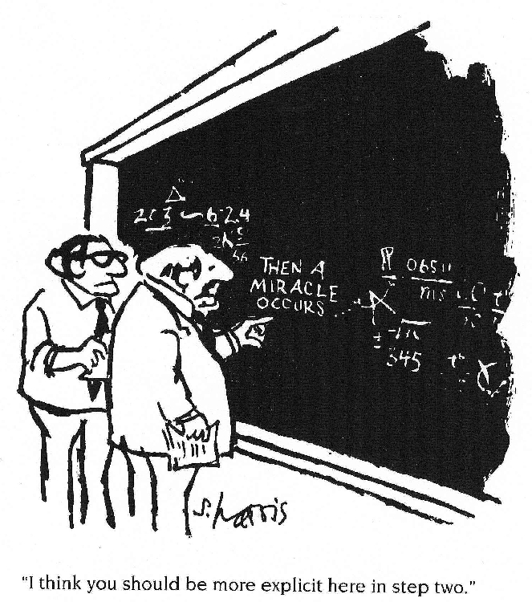

1. Professor Humphreys defined various types of miracle. Write down at least three examples of each kind in the table below:

Type of Miracle | Examples
Scientific Miracle
False Miracle
Biblical Miracle of Timing
Biblical Miracle against Natural Laws

2. Professor Humphreys says that his religious faith is more important to him than his work as a scientist, but that he doesn’t see them as being in competition. God, he says, uses science to run the universe. Explain in your own words below how his picture (or analogy) of God as a Composer helps in explaining why he is happy to believe in miracles which go against the laws of nature.

