Miracles
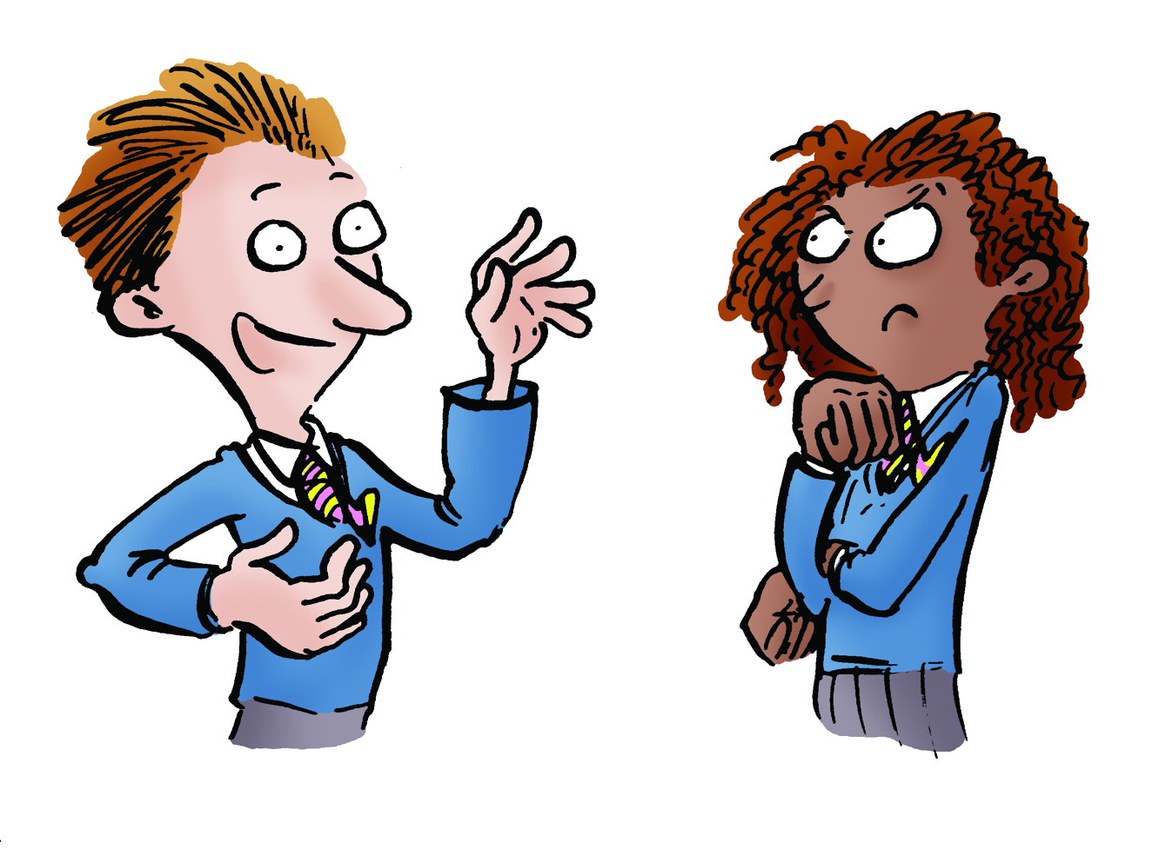

Key Aims of Session:

- To provide children with an opportunity to consider the concept of a miracle as an event which breaks the laws of nature and to discuss and reflect on some of the views held by scientists about these.
- To enable children to develop the skills to discuss their own views of such topics respectfully, with a clear explanation of their line of reasoning, in the context of a discussion of miracles.
- Teaching note: it is important that children do not assume that while a miracle is a work of God, a medical cure is necessarily nothing to do with God. Scientists with a religious faith believe that God created a world that is open to scientific enquiry and so we can discover and apply that knowledge. Thus miracles are times when God acts in different ways from normal as a special sign. God’s normal ways are what we describe in 'scientific laws.’

National Curriculum Links
Curriculum Framework for Religious Education in England and Wales
Key Stage 2 (Primary) - C1. Discuss and present thoughtfully their own and others’ views on challenging questions about belonging, meaning, purpose and truth, applying ideas of their own in different forms including (e.g.) reasoning…
English – Spoken Language
- listen and respond appropriately to adults and their peers
- ask relevant questions to extend their understanding and knowledge
- consider and evaluate different viewpoints, attending to and building on the contributions of others
Learning objectives:

- To be able to understand and apply a definition of miracles as events that break the laws of nature.
- To understand that different scientists and different people from the same religion have different views on miracles.
- To be able to explain their own views on miracles, in a manner that is respectful to others who may disagree and clearly explains their line of reasoning.

Differentiated outcomes:

ALL:
- Can give the definition of miracles used in this lesson and identify some examples of events that are and are not miracles.
- Can identify some of the views given by other people in some of the materials in this lesson
- Can say whether or not they believe that miracles are possible.
MOST:
- Can apply the definition of miracles to the examples given in this lesson and explain why they would or would not be categorised as miracles under this definition.
- Can identify differences and similarities between the views of different people discussed in this lesson and are aware that not every scientist or every person from the same religion would hold the same view.
- Can explain their own view in a manner respectful to the views of others in their class, explaining how they arrived at that viewpoint.

SOME:
- Can distinguish perceptively between the different views of different scientists and people of the same religion, pointing out the more subtle differences in their views.
- Can explain their own viewpoint in a manner that is respectful to the views of others, and identify the distinctions between their own views and the views of others. Shows awareness of complexity in their discussions.

Lesson in context/prior learning:

- That miracles are described in a range of religious texts.
- That science explains how the world works and that we can predict, using laws of science and nature, what we might reasonably expect to be possible within those laws (e.g. if I drop a pen on earth, it will fall due to gravity.)

Resources:
- Sheet 1: Card Sort
- Texts giving examples of miracles from faiths that the children are familiar with, for example due to prior study or due to children of that faith being present in the class (examples provided on Sheet 2, but these are not an exhaustive suggestion list)
- Sheet 3: Speech Bubbles
- “Can a scientist believe in miracles?” video at http://www.faradayschools.com/can-a-scientist-believe-in-miracles/

Session Plan:

Element | Purpose | Timing | Summary
Learning orientation | To introduce the lesson and key definition | 5 minutes | Explain what we will be learning about today in simple terms.  Ask the children to think-pair share a definition of miracles, and then share the definition we will be using today of miracles as “Events that break the laws of nature.”  Explain that there are no right answers, but that the best ideas will clearly explain your reasoning and be explained in a manner that is respectful to others even if they disagree.
Card Sort | To allow children to rehearse application of the definition and teacher to check understanding | 5 minutes | Ask children to work in groups to sort the cards on Sheet 1: Card Sort to identify whether they are miracles, not miracles or whether more information is needed in order to decide.  Explain to children that although we are looking at miracles as ‘special’ acts of God, religious people believe God acts in other ways too – and for example, has created a universe in which we can discover knowledge which we can apply to develop medicines
Miracles from Religious Texts/Contexts | To introduce children to miracles from a range of contexts | 10 minutes | Give each group a different miracle text and ask them to read it and identify the features which would lead people to call it a miracle.
Mini-plenary | To check understanding | 5 minutes | Each group to feedback to class.  Teacher to address any misinterpretation of the miracle definition.
Whole class teaching. | To demonstrate that people within one religious faith may interpret key ideas from their faith differently. | 5 minutes | Explain that the speech bubbles that the children are about to be given give views from different Christians about their religion. Ask them to predict what the Christians are likely to say and record this on a board for comparison.  Provide the children with the speech bubbles and ask if they children find any surprising.
Small Group discussion | To allow children to rehearse skills of explaining their viewpoint and agreeing and disagreeing respectfully | 5 minutes | Give each group one or more speech bubbles and ask them to discuss whether they agree or disagree.
Mini-plenary | To assess and feedback on ability to give clear line of reasoning in a respectful manner | 5 minutes | Take feedback from each group. Discuss as appropriate with the class
Video stimulus | To consolidate understanding of what makes a miracle distinct from a surprising or pleasing event  To provide an example of a scientist who believes in miracles. | 15 minutes | Tell the children that they are about to watch a scientist talking about religion.  Ask for their predictions of what he will say.  Watch the video listed in the resources, up to the point when the pupils start sorting out pieces of paper together.  You may wish to stop and start the video to check for understanding and/or to apply the ideas from earlier in the lesson.
Main plenary | To consolidate learning | 5 minutes | Encourage the children to discuss whatever has been most interesting about the learning today.  Ask them to think-pair-share their ideas as to whether miracles are possible.

Sheet 1: Card Sort

Your parents win a million pounds. | A woman with cancer has treatment in hospital and gets better.
You get 10 out of 10 on a spelling test. | A blind man is suddenly able to see.
A person is able to walk on water. | There is a huge storm. Someone asks God to stop the storm and suddenly it is sunny.
A magician on TV makes an elephant disappear. | Snow is forecast and a school trip you really want to go on will be cancelled if it snows. You pray that it doesn't snow and there is no snow.
A statue cries salty tears. | A scientist discovers a way to cure a disease that causes blindness

Sheet 2: Example Miracle Texts

Jesus Changes Water into Wine (John 2:1-11)

On the third day a wedding took place at Cana in Galilee. Jesus' mother was there, and Jesus and his disciples had also been invited to the wedding. When the wine was gone, Jesus' mother said to him, "They have no more wine." "Dear woman, why do you involve me?" Jesus replied. "My time has not yet come." 5 His mother said to the servants, "Do whatever he tells you." Nearby stood six stone water jars, the kind used by the Jews for ceremonial washing, each holding from twenty to thirty gallons. Jesus said to the servants, "Fill the jars with water"; so they filled them to the brim. Then he told them, "Now draw some out and take it to the master of the banquet." They did so, and the master of the banquet tasted the water that had been turned into wine. He did not realize where it had come from, though the servants who had drawn the water knew. Then he called the bridegroom aside and said, "Everyone brings out the choice wine first and then the cheaper wine after the guests have had too much to drink; but you have saved the best till now." This, the first of his miraculous signs, Jesus performed at Cana in Galilee. He thus revealed his glory, and his disciples put their faith in him .

Moses Parts the Red Sea (Exodus 14:21)

Then Moses stretched out his hand over the sea, and all that night the LORD drove the sea back with a strong east wind and turned it into dry land. The waters were divided.

The Miracle at Panja Sahib

Guru Nanak was resting. His follower, Mardana, felt thirsty and asked what to do. Guru Nanak told him to go up a small hill nearby where there was a spring and drink. The owner of the spring, Wali Shah, did not allow Mardana to drink. Nanak called on the Gods and the spring dried up and the water trickled down at the feet of Nanak. In his anger, Wali Shah of the spring threw down a boulder. Nanak stopped the boulder with his hand and his handprint is still there to be seen.

Sheet 3: Speech Bubbles
I don’t spend time thinking about if the miracles really happened. I am interested in the meanings within them and what they tell me about God and how to live my life.

If God could create the universe, it is a bit pedantic to question whether He could do something much smaller like part the Red Sea. Of course I believe in miracles.

I am a scientist first and foremost. If I can explain a miracle using science, I will accept it, if not the account in the Bible is inaccurate, but an important metaphor.
I believe in the Bible. Therefore I believe the miracles did happen.
I am not sure if I believe in the physical resurrection. That doesn’t make Jesus, the Bible or my religious beliefs any less important to me.
God is omniscient (all knowing) and omnipotent (all powerful). Therefore I don’t expect to understand everything He does. I think all the miracles are scientifically possible, just not in our limited understanding of the rules of science.
If God made the laws of nature, then He can bend them.

