Fossils – Fossilisation
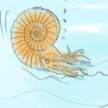
Key Aims of Session:

- Fossils can tell us about living things that were on Earth millions of years ago.
- Fossils can help us work out the evolutionary history of life on Earth and how life on Earth has changed over time
- Fossils are made of rock, they are the per-mineralisation of living things that have been buried and exposed to mineral rich water.

National Curriculum Links
Key Stage 2 (Primary)
- Recognise that living things have changed over time and that fossils provide information about living things that inhabited the Earth millions of years ago.
Learning objectives:
- To understand that fossils are evidence of life that existed thousands or millions of years ago.
- Fossils occur due to an organism being buried in sediment and exposed to mineral rich water. Over time, the minerals replace the organic parts of the organism and form a hard rock in place of the organism.
- Palaeontologists find these fossils and can date them based on the age of rock they are found in.
- Fossils provide evidence that supports the theory of evolution; the fossils we find are of life that was on Earth thousands or millions of years ago. All life we see today has evolved from living things that existed millions of years ago.

Differentiated outcomes:

After this lesson, students should be able to:
- ALL: State that fossils provide evidence of living things that were on Earth thousands or millions of years ago.

- MOST: Describe how a fossil forms

- SOME: Explain that fossils are evidence of what life there was in the past and how living things today have evolved from things that lived in the past.

Lesson in context/prior learning:
This session looks at how an ammonite fossil is formed. It builds on the teaching they had in Year 3 on fossils. It explains how fossils are formed using an example of an animal that lived millions of years ago. Throughout the session the pupils are taught that fossils are evidence of evolution as we can see how life today is different to life in the past. Fossils provide a snapshot of the kinds of things that lived at different times in the past.

The key idea for pupils is how fossils are formed and that they are used as evidence of evolution. They provide us with information on what life there was thousands or even millions of years ago.

Resources:
- Work sheets (1 sheet per pupil)

Session Plan:
(What the children (and teacher!) need to know before they start this lesson)
Element | Purpose | Timing | Summary
Learning orientation | Introduce the lesson and key purpose | 5 minutes | Explain we will be learning about fossils and evolution, ask children to think-pair-share what a fossil is and how these are formed. Fossils can be dated based on the rock they are found in, which allows us to understand how life has changed over thousands and millions of years through evolution.
Activity | Fossilisation process | 10 minutes | Children will each have a sheet of the fossilisation process out of sequence. Children will number each stage in the order they think the process occurs.
Plenary | Understanding of how fossils are made and that life today has evolved from things that lived in the past. | 5 minutes | Go through the sheet giving the correct answers and talking through the process of how fossils are formed. Talk about the ammonite and how it is an example of something that lived in the past but is no longer around today. Fossils from different times are used as evidence of evolution.

Plenary: Bring the class together and talk about how fossils are made. Fossils are evidence of what life there was thousands and millions of years in the past. They are used as evidence of evolution. We can use fossils to see how life has changed over millions of years. The next lesson will be learning about different fossils and how we can tell how old a fossil. The class will be making a Fossils Jelly model!

Fossilisation of an ammonite
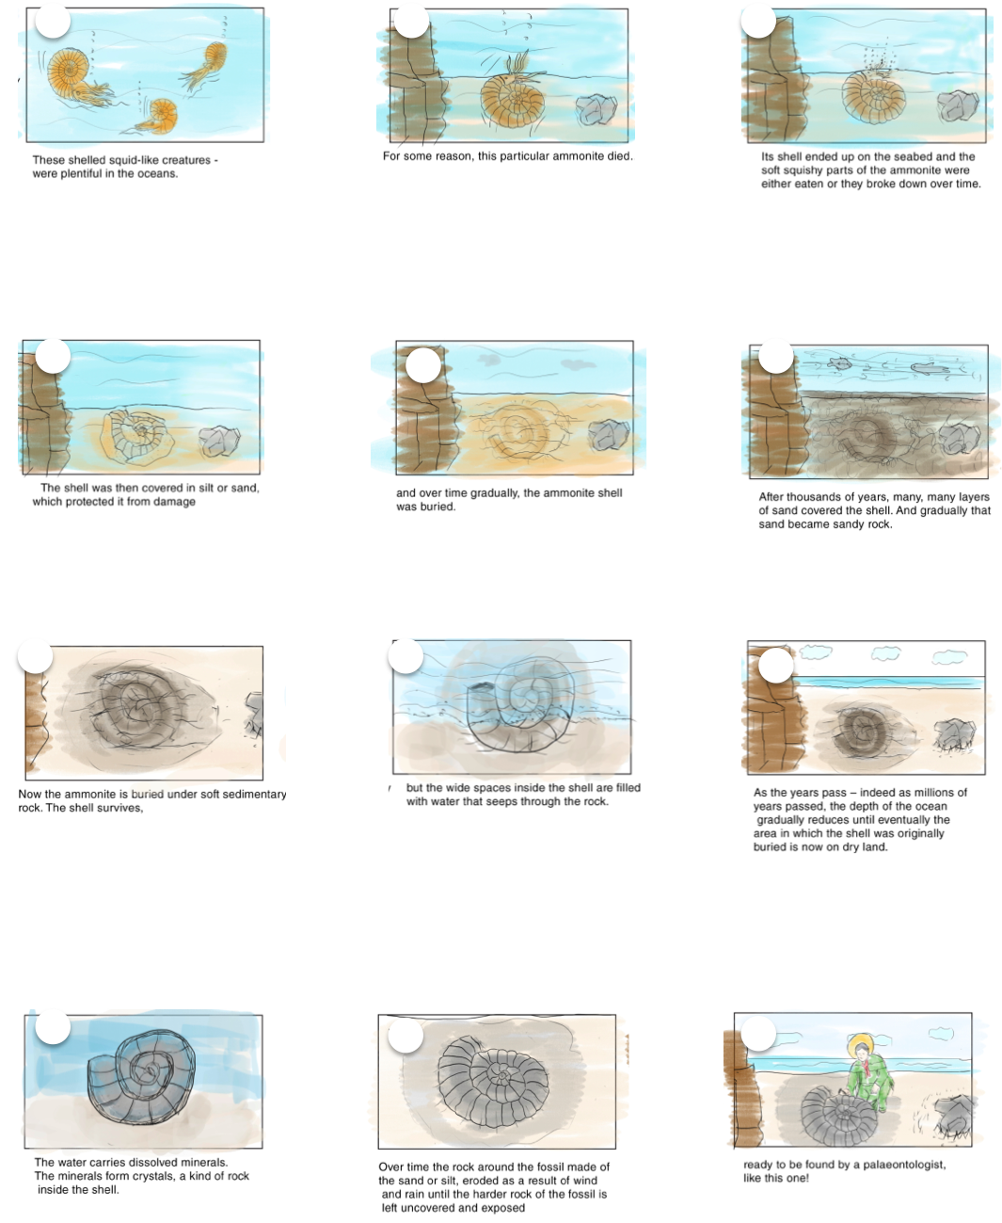
Teachers sheet – Correct order

Fossilisation of an ammonite
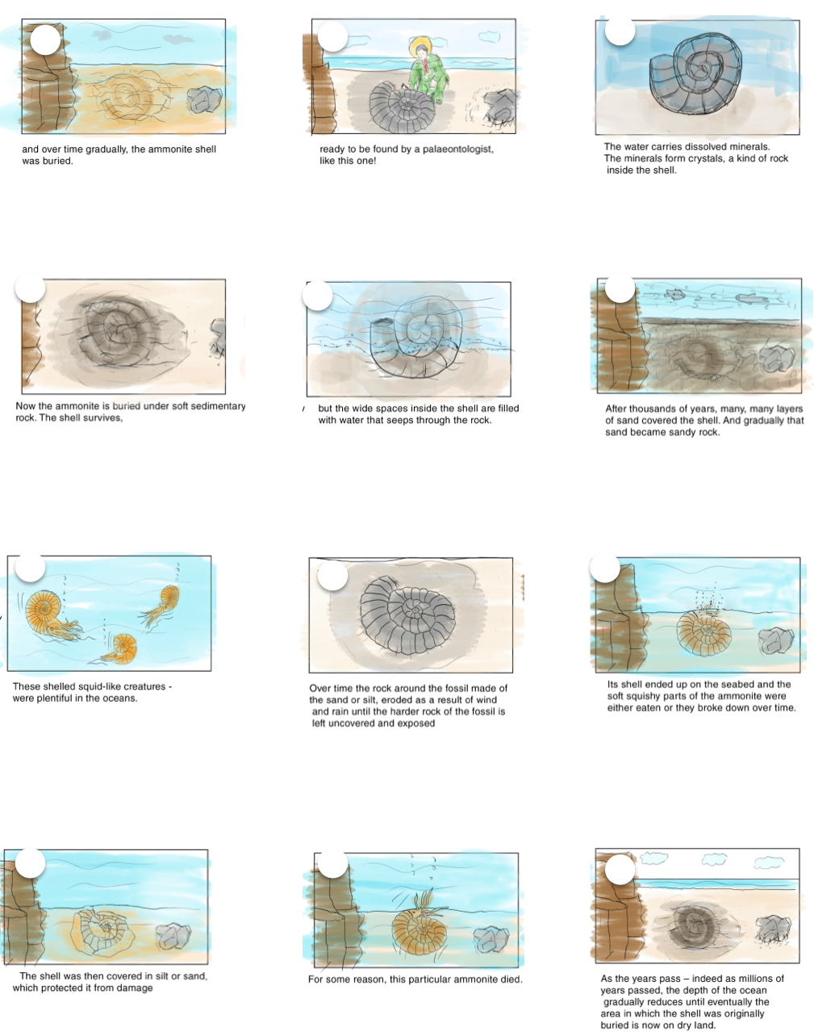
Cut and stick the images into the correct order! Or number the circles in the images.

