Evolution and Religion: Mary Anning – Embracing faith and science 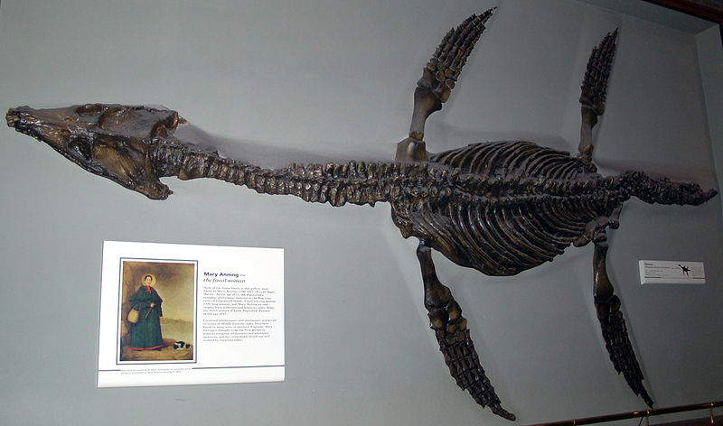

Key Aims of Session:

- Science and religion can fit together
- Science addresses questions about how nature works. Religion is mostly concerned with different types of questions – such as questions of ultimate meaning and purpose.
- Ensure children know that many people in science are also religious
- Provide a cross-curricular approach linking the evolution and inheritance unit to optional curriculum points in religious studies.

National Curriculum Links
Science Key Stage 2 (Primary)
- Recognise that living things have changed over time and that fossils provide information about living things that inhabited the Earth millions of years ago.
The non-statutory RE Framework 2013
Key Stage 2 (Primary)
- Pupils discuss different perspectives on questions about the beginnings of life on Earth, so that they can describe different ways science and religions treat questions of origins

Learning objectives:
- Be aware that the scientific community is diverse and there are people in science who have and who do not have a religious faith.
- Understand that Mary Anning is an example of a woman who advanced our scientific understanding of the life that was on Earth millions of years ago. Mary was religious and was commended for her advances in science by scientists and the Church of England.

Differentiated outcomes:

ALL: Mary Anning was a scientist and religious.

MOST: Will be able to explain how Mary Anning studied fossils, which show us what lived thousands and millions of years ago and was a leading expert in her field. She was also a Christian.

SOME: Explain that you can be a scientist and also religious. Mary Anning found fossils and advanced our scientific understanding of what living things might have looked like long ago. The geological society and the Church of England commemorated Mary Anning for her advances in science.

Lesson in context/prior learning:
Mary Anning is referenced in the Primary Science Curriculum guidance notes for evolution and inheritance. This unit explores Mary’s life and beliefs as an example of a scientist with a religious faith who lived in the past and who studied fossils. Fossils provide information about what living things existed millions of years ago.
Pupils should already be aware of what a fossil is and how fossils are made from previous lessons both in Year 6 and in other years that look at fossils i.e. Year 3.
Pupils will be asked to consider the idea that science and religion can go together – they are not necessarily in conflict. Mary Anning is an example of a leading scientist that was also religious.
The session looks at the life of Mary Anning. It also delves into how she searched and found fossils as a child. As she collected these fossils and grew up and went to school, she built up her understanding of fossils. She used evidence from the fossils to figure out what things lived in the past.
The key idea for students is that science is an exciting career for people from a range of backgrounds.

Resources:
- PowerPoint presentation
- Quiz answer sheets
- Optional quiz prize!

Session Plan:

Element | Purpose | Timing | Summary
Learning orientation | Introduce the lesson and key purpose | 5 minutes | Explain that we are going to learn about science and religion. How they can go together and we will be looking at an example of this in Mary Anning. See if any children have heard of her before. Mention she looked at fossils and get the children to think-pair-share either what a fossil is or ask children whether they think science and religion go together.
Introduction of contemporary religious scientists | Expose children to examples of scientists who are also religious | 5 minutes | Select a diverse range of current scientists who are also religious. Emphasise that they are specialists in many different scientific disciplines who are also religious.
Mary Anning Presentation | Provide an in depth look at a scientist who was also religious | 15 minutes | Mention a quiz on the presentation! Mary Anning grew up in Lyme Regis. A great place to go fossil hunting. As she grew up her knowledge of fossils increased and she became a leader in her field of fossils. Throughout her lifetime she was religious. She regularly read the Bible and looked to God and scripture in times where she felt closer to God, e.g. after scares from landslides when fossil hunting. She was Anglican and was commemorated when she dies by the Church of England and the Geological Society of London. She was the first woman to have a stained glass window made in her honour to acknowledge her advances in science.
Main activity | To recap in depth on the life of Mary Anning who embraced her passion for science and faith. | 10 minutes | Following the presentation, the class will be in teams for the quiz on Mary Anning. Read out the questions to the group – all questions are covered on the slides or slide notes that are read out at the time of the presentation.  Quiz answers are at the end of these notes.
Main plenary | Children need to understand that science and religion are not in necessary conflict with each other. | 5 minutes | The teacher will re-cap on the information they have covered. Discuss the many different religious scientists from a broad range of disciplines. Repeat that Mary Anning was a great example of a person who embraced her faith throughout her life. She also was a leading specialist in her field of science – fossils.

Plenary: Conclude to the class that there are many religious people who are also scientists. Science and religion do not necessarily go against each other. The scientific community consists of a diverse group of people.

Mary Anning Quiz Answers

- True or False: Mary was a scientist who loved studying fossils?
True
- True or False: Mary happily lived her life embracing her passion for science as well as her religious beliefs?
True
- Where in the country were the rocks she went fossil hunting for?
Lyme Regis (Half Mark for Dorset or Devon)
- What was her dog’s name?
Tray
- Mary was nearly crushed by a runaway what?
Cart (No marks for landslide)
- How much money did Mary get for selling some of her fossils?
£100-200 OR Over £150,000
- What year was Mary Anning born?
1799
- What was the name of the famous fossil Mary found?
Plesiosaur OR Sea Dragon
- What was Lyme Regis near to 200 million years ago?
The equator
- List 3 of the nicknames for fossils. (1=zero marks, 2= half mark)
Curiosities, vertiberries, snakestones, ladies fingers, devils toenails.
- What was Mary’s religion?
Anglican OR Christian
- What was the society that put a window up in memory of Mary?
The Geological Society of London
- Where was the window placed?
Local Church
- Who else helped put the window up?
The local Vicar

