Science and Creation

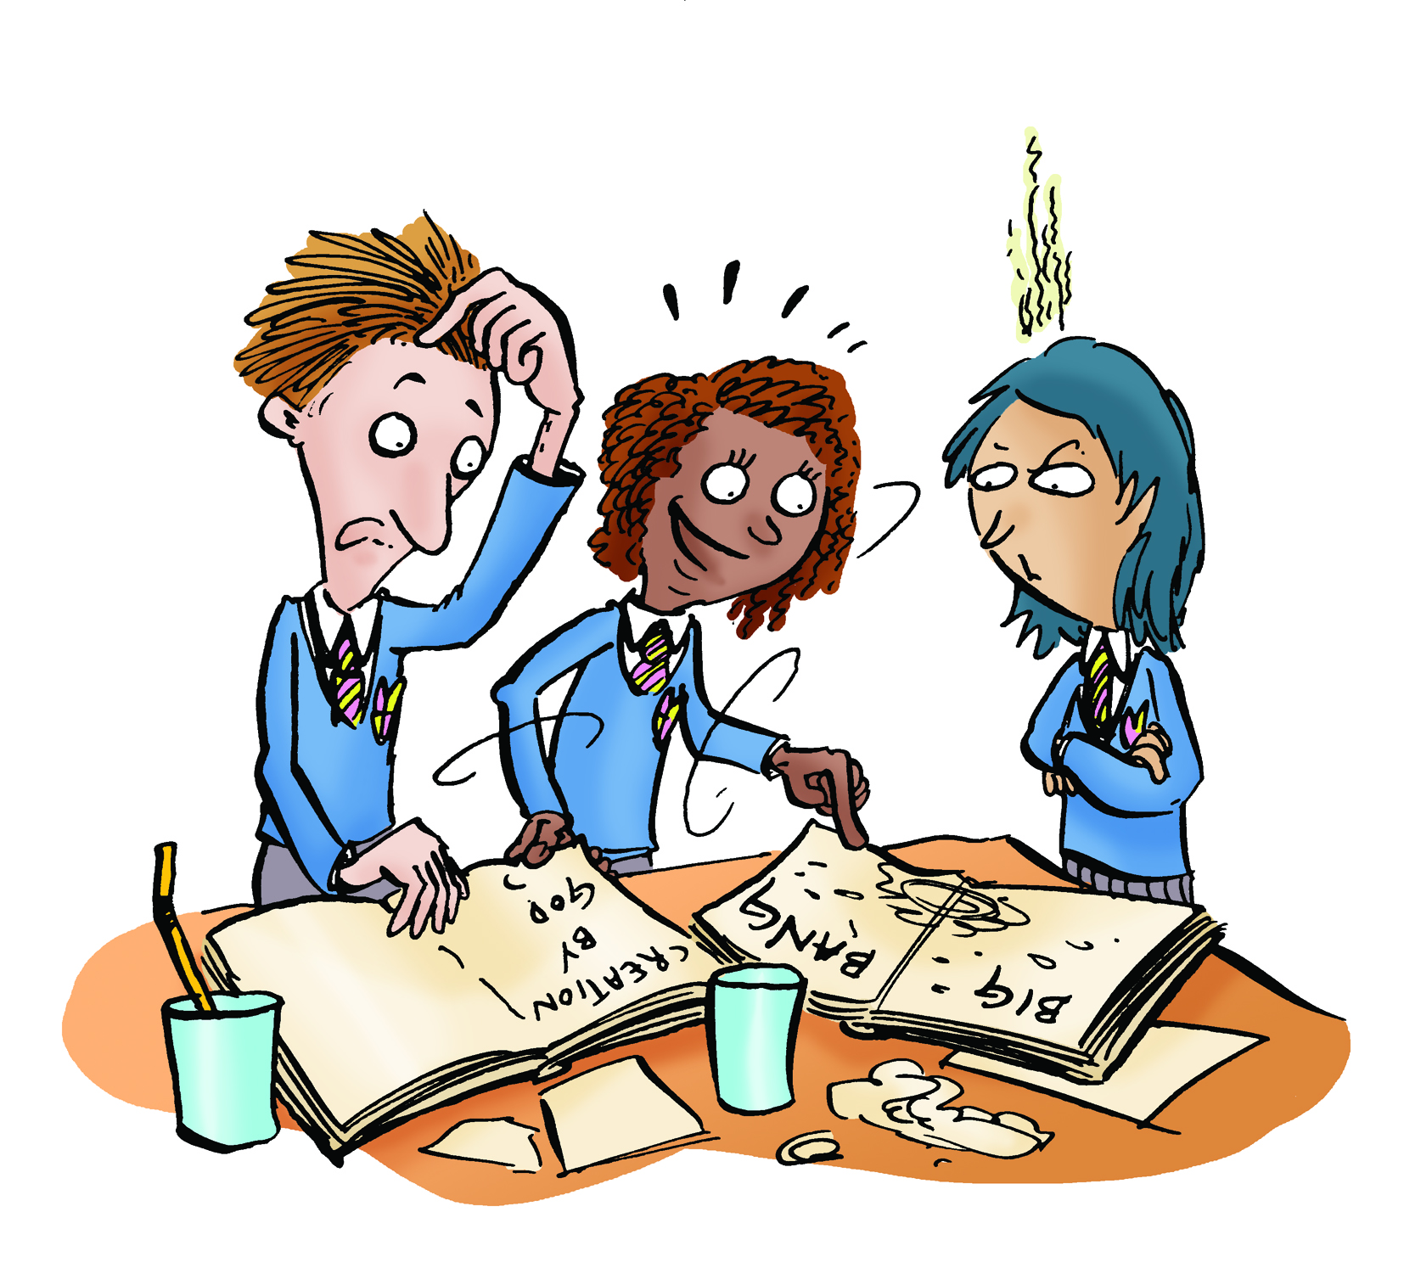

Key Aims of Session:

- To show that science and religion are mostly focused on different kinds of questions

National Curriculum Links
The non-statutory RE Framework 2013
Key Stage 2 (Primary)
- Pupils discuss different perspectives on questions about the beginnings of life on Earth, so that they can describe different ways science and religions treat questions of origins

Learning objectives:
- To investigate why there are different views about how science and religion relate. To consider the idea that it’s possible for two claims to be different but both true. An example is, “the kettle is hot because I’m making a cup of tea”, “the kettle is hot because the element heated the water.”

Differentiated outcomes:

ALL:
- Know that some scientists believe in God and some do not.
- Understand that the Big Bang theory is supported by observations.
- Understand that Creation stories are considered by many people to be written in poetic language.

MOST:
- Understand that creation stories were not written to answer the types of questions that science asks.
SOME:
- Understand that scientific ideas are relatively robust because they are supported by objective and repeatable observations. But not all ideas can be tested this way.

Key ideas:
- Scientific and religious enquiries are usually focussed on different kinds of questions.
- Science explains how nature works. Scientific ideas can be tested by gathering observable evidence and by doing experiments. Scientific enquiry is a robust form of enquiry but it cannot tackle every kind of question.
- Religion addresses questions about ultimate purpose. Religious creation stories explain that God created the universe.
- Religious ideas are supported by evidence and reasons that may be subjective, personal and tentative. One person may see the beauty of the universe as a reason to believe in God while another does not
- Some people with a religious faith believe that religious texts offer a literal account of the steps that God took to create the universe while some others believe that the account is metaphorical.

Resources:
- PowerPoint Creation and Science
- Detective Sheet 1: Observation
  - Bottles of diet cola and various sweets
- Detective Sheet 2: Writing Challenge

Element | Purpose | Timing | Summary
Hook | To create a dialogue about science and religion | 5 minutes | Discuss as a class: What is the meaning of religious Creation stories? Which religious texts do pupils know about? (Bible, Qur’an etc). Why do people watch science shows on TV that are about How the Universe began? Have pupils seen any science shows on this? What ideas were discussed?
Starter | To identify what students think about how science and religion work together | 5 minutes | Ask pupils to discuss in pairs how they make sense of the ideas from science and religion when thinking about how the Universe began. Ask some pairs to describe their discussions to the class.
Investigation | To allow children to do an experiment and record their observations. | 15 minutes | Give out Detective Sheet 1: Experiment. Be a scientist and do experiments in small groups with diet cola and sweets. NB experiment works best with diet cola because it doesn’t have sugar so it is easier to clean up.
Plenary | To consider the idea that Science and Faith focus on different questions. | 20 minutes | Use Science and Creation PowerPoint to show evolution and the creation story. Look at an example of descriptive text and discuss if science and faith can fit together.
 | To encourage children to see that texts in different styles may have different purposes and allow children to write their own examples | 15 minutes | Give out Detective Sheet 2: Writing. Compare writing styles by making a poem about your favourite food and then writing instructions on how to make it.

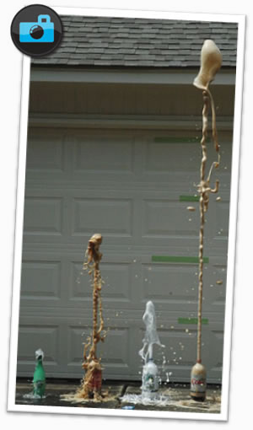
Detective Sheet 1: Experiment

1) What happens when sweets are dropped into diet cola?
What has this got to do with the beginning of the universe?
Well, Science is about observation. So, let’s be scientists and observe!

When scientists experiment, everything is carefully controlled. See what happens, then change one thing and do it again. Remember to make notes of your observations.

What happens when you drop different sweets (mint, gummy, sugary…) into diet cola?

Make a hypothesis – which kind of sweet will produce the most froth and why.
Now test out your hypothesis by dropping each sweet into a new sample of coke.

Once finished, you can construct at theory about what happens when sweets of different types fall into diet coke. Your theory is supported by the evidence drawn from your observations.

EXPERIMENT (what you are going to do)
_____________________________________________________________________________________

_____________________________________________________________________________________

HYPOTHESIS (which sweet do you think will cause the most froth and why?)
_____________________________________________________________________________________

_____________________________________________________________________________________

OBSERVATIONS (watch what happens)

TEST 1 (what you did and what are the results) | TEST 2
TEST 3 | TEST 4

CONCLUSION (which sweet produces the most froth – and how do you know)
_____________________________________________________________________________________

_____________________________________________________________________________________

_____________________________________________________________________________________

Detective Sheet 2: Writing

Now, here’s a writing challenge for YOU!
Can you write a poem that explains the wonderful appearance and delicious taste of your favourite plate of food? What is the food and can you persuade your readers to love it as much as you do? Now suppose you are writing a set of instructions to explain how to make this food – can you make it really clear so that readers know what to do?

Compare these two pieces of writing.
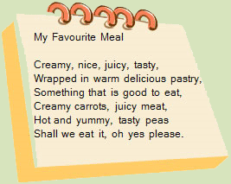 | My favourite Meal:  To make the pastry:  Sift flour into a bowl. Cut butter into small pieces and add to flour.  Rub in the butter and add cold water.  For the filling:  chicken, potato, carrots, peas.  Cook for about 20 minutes.

What are the purposes of each and how are they different?

_____________________________________________________________________________________

_____________________________________________________________________________________

How does this help you to think about the different types of writing in a religious creation story and in a science text book?
_____________________________________________________________________________________

_____________________________________________________________________________________

Now have a go – can you write a poem and a set of instructions about your favourite meal?

